* 1. **ABOUT THE PROJECT**

The project named Driving School Management System is to create a fully computerized system implemented to carry out the day to day work of a driving school in a smooth and organized way and also to reduce the manual process and online as more efficient. Through this website we are discussing how we can manage a driving school through online. Through this website if a person want to learn driving then he or she can register through this website and can select the driving schools nearer to them. The admin will permit them. This system stores the data of customer and school in their database. Driving schools can also register through this website. This system will store all the records related to trainer, customer information, course details, vehicle details, slot details and driving schools details. The main aim of the project is to provide an effective working platform to computerize the whole admission system and payment system. After the implementation of this project, customers can take admission in driving schools through online.

Most driving schools around the world still use physical books to schedule classes and keep records. This method is outdated, unreliable, not readily accessible and sometimes inaccurate. Driveon is a Driving school management system that handles almost all tasks done daily by driving schools.

The project is computerizing a driving school system that has various driving schools and customers and deals with its day to day work schedules. The customer can avoid delay by using the system. It is very smooth, efficient and fast system. This system makes class scheduling an easy job for the driving schools. It is very helpful for the customers and trainers. For the trainers in the driving school, the dealings of the trainers can handle very easily. The manual system had many difficulties and limitations. Through the process of computerization, the manual system overcomes the difficulties and limitations. We had designed the system to overcome these limitations.

Advantages for the Project

1. The system accepts customer registration for driving school through online.
2. Easy payments for customers based on their details in the database.
3. A customer can login to the system and view their scheduled classes.
4. The administrator can block the customers and schools if there is any issues.
5. The system is very fast and efficient application for driving schools work.

Front End: PHP

Back End: SQL

2.1. SYSTEM STUDY

System study refers to the process of examining a situation with the intent of improving it through better process and methods. System study is, therefore the process of gathering and interpreting facts, diagnosing problem and using the information to recommend changes in the system, in other words it means a detailed explanation of description. Before computerizing a system under consideration, it must be analyzed. We need to study how it functions currently, what are problems and what are the requirements that the proposed software should meet.

The main components of making software are:

* System and software requirements analysis
* Design and implementation of software
* Ensuring, verifying and maintaining software integrity

The online paint store management provides user friendly interface which can be operated by anyone with little knowledge about the computer system. It stores the information needed by the shop in a database which can be accessed by the administrator and customer. It should maintain a well organized database for storing the information regarding the shop. This helps to eliminate the storage of invalid data.

2.1.1 Existing System

In existing system, to manage the Driving schools we use a manual system. In the present system all the activities are performed manually. All data entry is performed by writing data into the book, paper documents .The record are prepared manually , so there is a chance for occurring errors and the calculations are not so accurate. Various information such as trainer details, customer details, time scheduling for driving classes and payment details are handled manually. When there is need for retrieving details searching is unavoidable, this is a difficult task searching the records manually.

The existing system uses manual method for whole process. This requires a lot of hard work and time consumption to complete the task. This may include human errors. In this existing system, it is difficult to retrieve some particular information. Also, all the records are stored manually and it is tedious task. As a result the security of these records is always a challenging task. Hence, the computerization of the system of record maintenance is the only solution to reduce the shortcomings of existing system.

Disadvantages of existing system

* Time consuming and improper planning and scheduling.
* High storage space.
* Less interactive.
* Requires more man power.
* High maintenance costs.
* Lots of paper work.

2.1.2 Proposed System

The proposed system is interactive, highly user friendly and designed exclusively for the Driving schools. The system covers almost all the functional areas of the Petrol Pump. The Online Driving School Management System is a database system used to store the information regarding trainer details, customer details, test details, time schedule for driving classes and payment details etc.

In proposed system everything is automated. This system Driveon automates the manual procedure of applying for admission in driving schools. It notifies the students about next session so no need of manually informing them. It provides secure payments. Tutors can directly get students address and slots that becomes convenient for them to visit the student directly. The system is convenient and flexible to be used. It saves their time, efforts, money and resources. They can view or edit their profile.

The computerization of the system allows the easy maintenance of the details. Large amount of data can be stored easily. In addition, updating and other changes can be done easily. The information can be retrieved with high speed and accuracy. The use of GUI oriented software makes the system user friendly.

Advantages of Proposed System

* High processing speed.
* Easy to retrieve old records by using report feature
* We can analyze trainer details, customer details, school details, course and payment details.
* The Online Driving School Management System shall provide the capability to back up the database.
* Minimal errors.
* Greater portability.
* User friendly.
* Reduced workload.
* Finding students details became easy.

2.1.3. Feasibility Study

Feasibility study is made to see if the project on completion will serve the purpose of the organization for the amount of work, time and effort spent on it. Feasibility study lets the developer foresee the future of the project and its usefulness. Finding out whether a new system is required or not .The study is carried out to the best system that meet performance requirement. This entails identification, description and evaluation of candidate system and selection of the best system for the best system for the job. It simply identifies whether the proposed system is feasible to the organization or not.

There are three aspects in the feasibility study portion of the preliminary investigation

* Technical feasibility
* Economic feasibility
* Operational feasibility

2.1.3.1. Technical Feasibility

The system must be evaluated from technical viewpoint first. The assessment of this feasibility must be based on outline design of the system requirement in the terms of input, output, programs and procedure having identified an outline system, the investigation must go on to suggest the type of equipment, required method of developing the system, method of running the system once it has been designed. The project should be developed such that the necessary functions and performance are achieved within the constraints. The project is developed with latest technology. There are only minimal constraints involved in this project.

2.1.3.2. Economic Feasibility

Here an evaluation of development cost weighted against the ultimate income or benefit derived from the developed system. The cost for the development of the project has been evaluated and we want to check that the cost does not exceed beneficial cost of the system. The economic and financial analysis is used for evaluating the effectiveness of the candidate system. This project also undergone economic feasibility study and found that it is feasible. So, the cost for development does not exceed its beneficial cost. This brought to as the conclusion that the system is economically feasible in the context.

2.1.3.3. Operational Feasibility

In operational feasibility the entire application is checked whether the system will be used if it is developed and implemented. Also, it is checked whether there will be resistance from user that may undermine the possible application benefits. There is no barrier for implementing the system. The system also helps to access the information immediately as need arises. Thus, the system is found to be operational feasible.

2.2. USER CHARACTERISTICS

The Driving school management system provides the user to perform their task in an easy and much less complex way to avoid redundancy. This system ensures that the users assessing the system can ensure maximum efficiency and they can depend on the system for desired results.

There are three user characteristics in this system:

1. Administrator
2. School
3. Customer

2.2.1. Administrator

Admin controls overall management of the system. Admin approves or rejects users. While doing registration to the site users must upload their aadhar details to prove himself. The students are approved on the basis of their aadhar identity, sslc certificate, and medical certificate of their eye. Schools are also approved on the basis of the license the uploaded. Admin view the profile of the students and the driving school.

2.2.2 Customer

School is the secondary user. School has limited privileges when compared to the administrator. School add the eligible trainers into the school. They can also add vehicles of different categories. They have the functions like allot sessions for students and view the allotted slot details.

2.2.3 Customer:

The customer will have little privileges when compared to both the administrator and school. They register into the site by entering their personal details. They can also view and update their details. Customer can view the school details and select the nearest school according to their likes.

2.3. SYSTEM SPECIFICATION

2.3.1 Hardware specifications

The selection of hardware is very important in the existence and proper working of any software .when selecting the hardware, the size and capacity requirements are also important .below is some of the hardware that is required by the system.

|  |  |
| --- | --- |
| Processor | Intel Core i3-3220 (3.3 GHz) or above |
| RAM | 4 GB or above |
| Storage | 512 GB or above |
| Other | Keyboard and Mouse |

2.3.2 Software specifications

|  |  |
| --- | --- |
| Operating system | Windows7/8/8.1/10 |
| Front end | PHP |
| Back end | SQL |

2.3.2 About software tools and platforms

PHP: Hypertext Preprocessor is a general purpose programming language originally designed for web development, it was originally created by RasmusLerdorf in 1994. The PHP reference implementation is now produced by the PHP group .PHP code may be executed with a command line interface(CLI) , embedded into HTML code or it can be used in combination with various web template systems, web content management systems and web frameworks

SQL: Server management studio is a software application first launched with Microsoft SQL server 2005 that is used for configuring, managing and administering all components with Microsoft SQL server. The tool includes both script editors and graphical tools which work with object and features of the server.

3.1. MODULES AND DESCRIPTION

Online Driving School Management System provides us facilities to manage the activities taking place in driving school. This system is developed to manage the work flow in a driving school. There are 6 modules in this project. They are:

1. School Registration
2. Customer Registration
3. Add Trainer
4. Add Vehicle
5. Payment Management
6. Add Slot

3.1.1 SCHOOL REGISTRATION

This module deals with the school details. The user can register their school in this system, and also we can search the school details. The personal details of the trainer are also being added to the system.

3.1.2 CUSTOMER REGISTRATION

This module contains the details about the customer in the Driving school. The user can register to their desired driving school. The admin will permit them.

3.1.3 ADD TRAINER

This module manages the trainer details. The school adds the trainers

3.1.4 ADD VEHICLE

This module manages the vehicle details, the school can add and search vehicle details such as vehicle id, vehicle number etc

* + 1. PAYMENT MANAGEMENT

This module manages the payment details, only card type payment is managed. We can add payment, edit payment and search payment.

3.1.6 ADD SLOT

This module manages the time schedule for the students. The time slot is set by the driving school.

3.2 DATA FLOW DIAGRAM

A data flow diagram is graphical tool used to describe and analyze movement of data through a system. These are central tool and the basis from which the other components are developed. The transformation of data from input to output, trough processed, may be described logically and independently of physical components associated with the system. These are known as the logical data flow movement of data between people, departments and workstations. A full description of a system actually consists of a set of data flow diagrams.

A DFD is also known as a “bubble chart” has the purpose of clarifying system requirements and identifying major transformations that will become programs in system design. So, it is the starting point of the design to the lowest level of detail. A DFD consists of a series of bubbles joined by data flows in the system.

In the DFD, there are four symbols



Process that transforms data flow



Source or Destination of data

Data store



 Data flow

Rules for drawing data flow diagrams

Rule 1: Establish the context of the data flow diagram by identifying all of

the net input and output data flows.

Rule 2: Select a starting point for drawing the DFD.

Rule 3: Give meaningful labels to all data flow lines.

Rule 4: Label all processes with action verbs that relate input and output data

flows.

Rule 5: Omit insignificant functions routinely handled in the programming

process.

Rule 6: Do not include control or flow of control information.

Rule 7: Do not try to put too much information in one DFD.

Rule 8: Be prepared to start over.

Level 0 DFD of Online Paint Store Management System

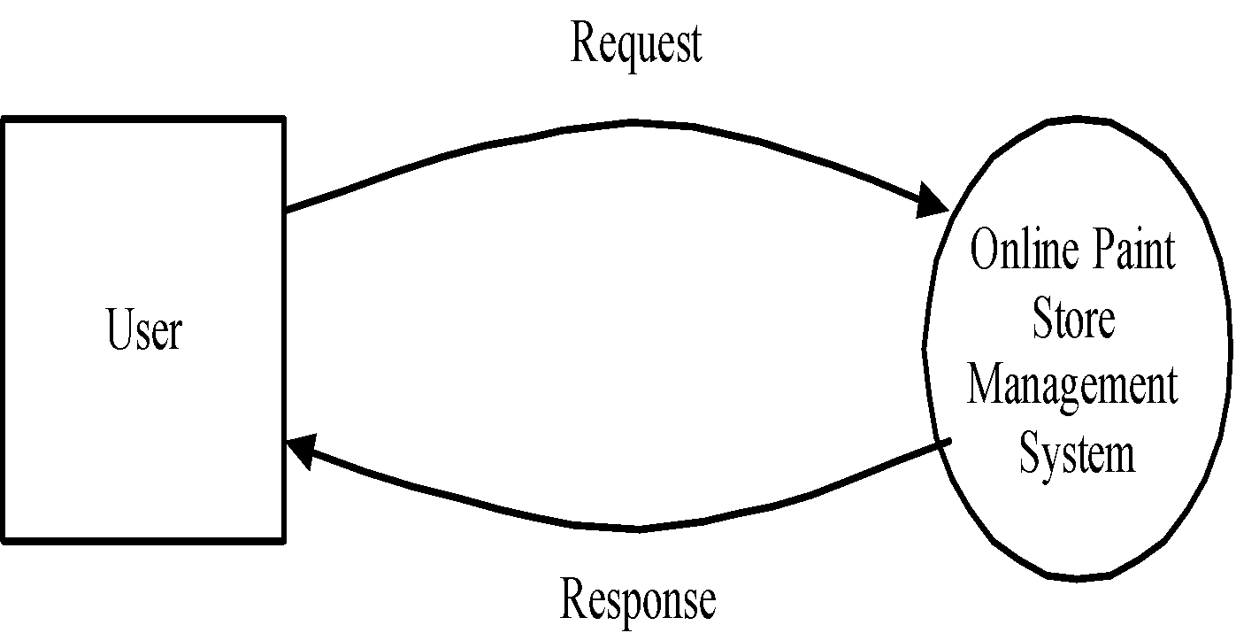

Level 1 DFD of Online Paint Store Management System

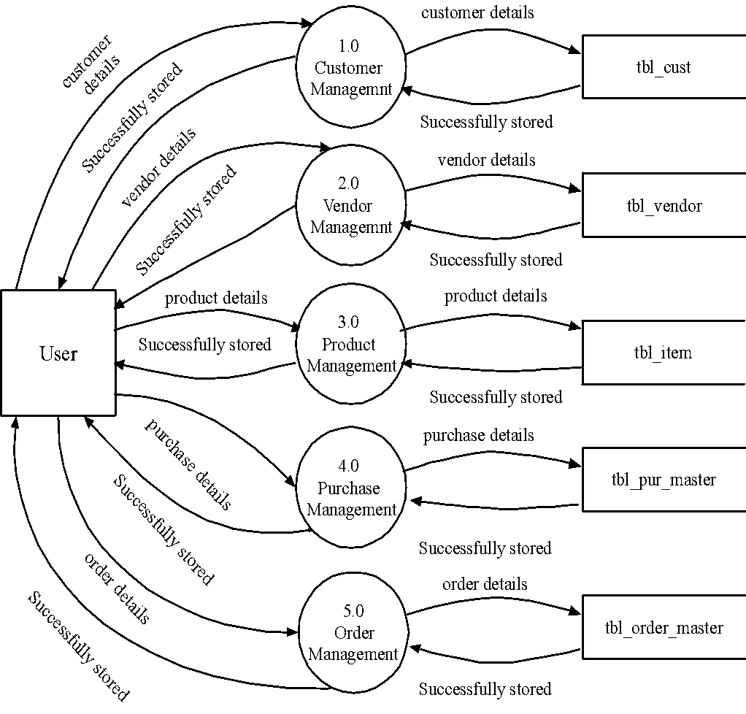

Level 2 DFD of Customer Management

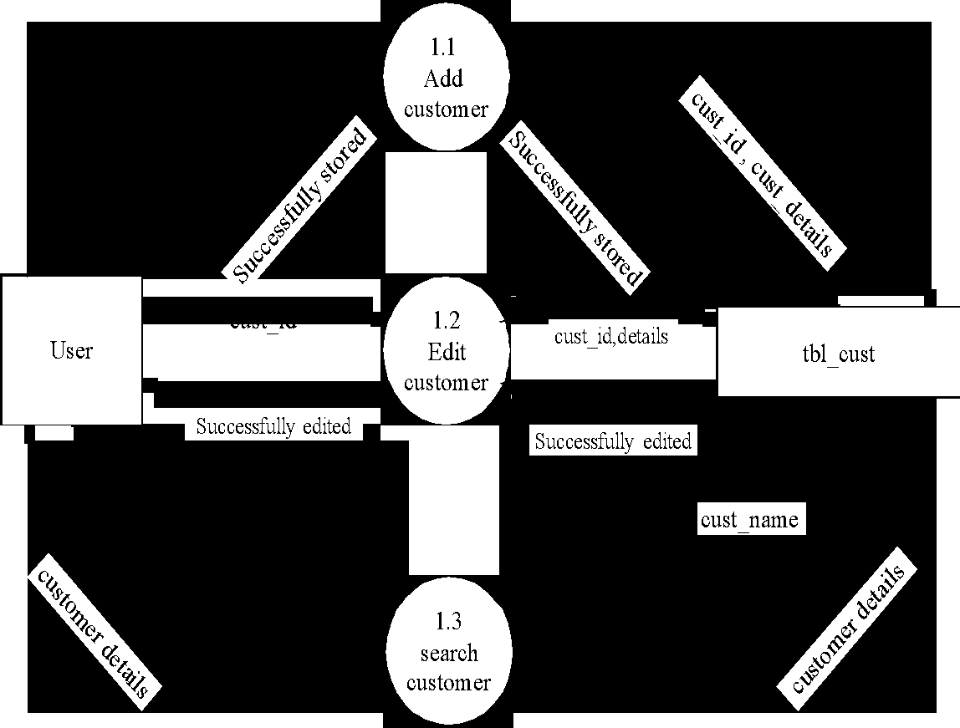

Level 2 DFD of vendor management

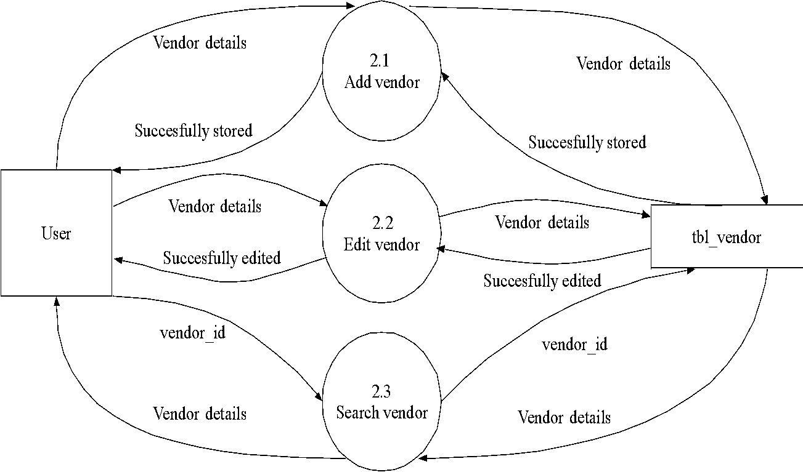

Level 2 DFD of Product Management

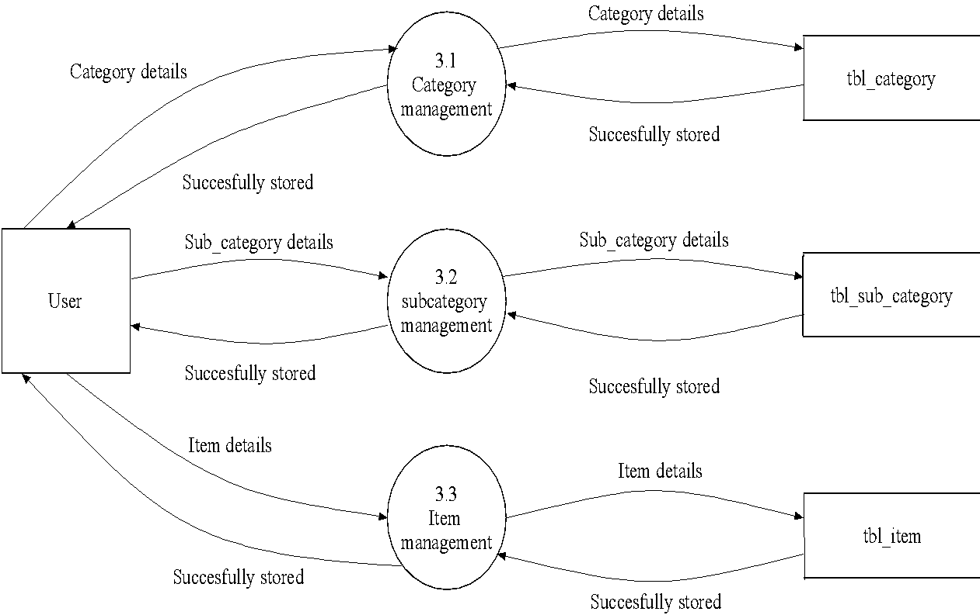

Level 2 DFD of Purchase Management

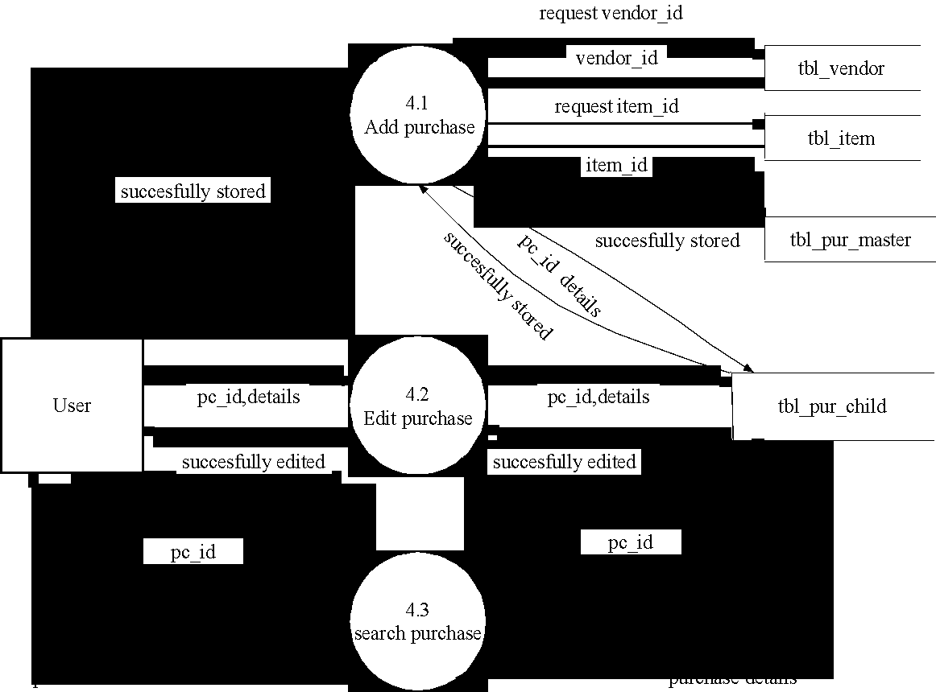

Level 2 DFD of Order Management

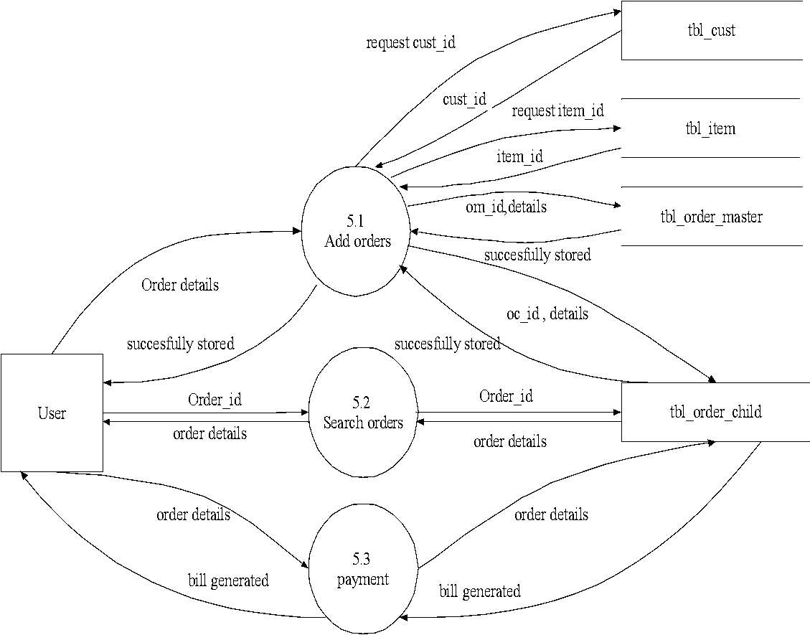

Level 3 DFD of Category Management

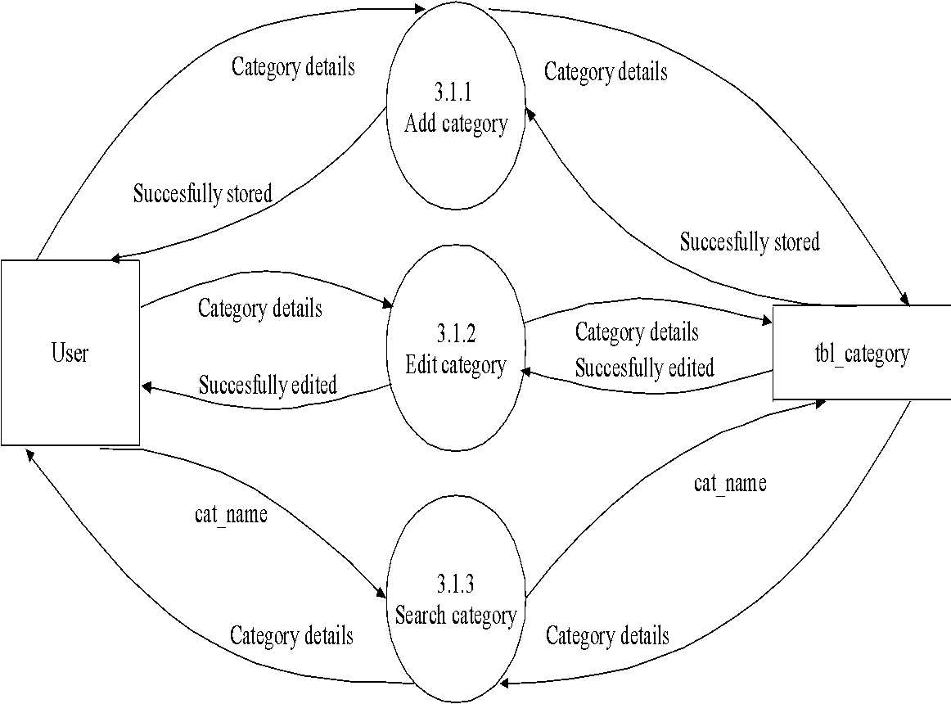

Level 3 DFD of Subcategory Management

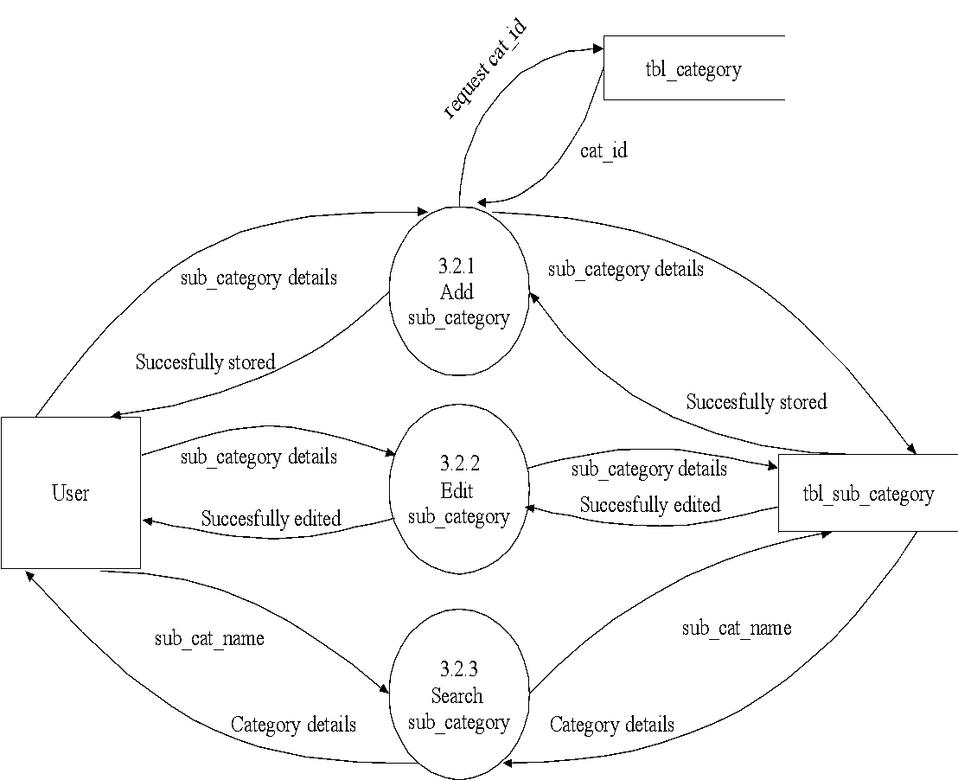

Level 3 DFD of Item Management

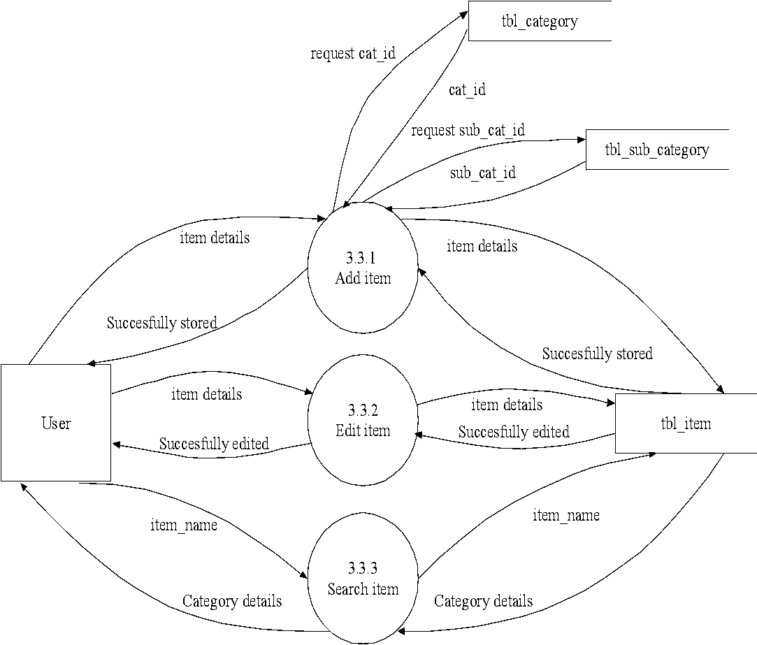

3.3 ENTITY RELATIONSHIP DIAGRAM

The ER model is a conceptual data model that views the real world as a construct of entities and associations or relationships between entities. A basic component of the model is the Entity-Relationship diagram, which is used to visually represent data objects. The ER modeling technique is frequently used for the conceptual design of database applications and many database applications and many database design tools employ its concepts.

 Entity Type

 Weak Entity Type

 Relationship Type

 Attribute

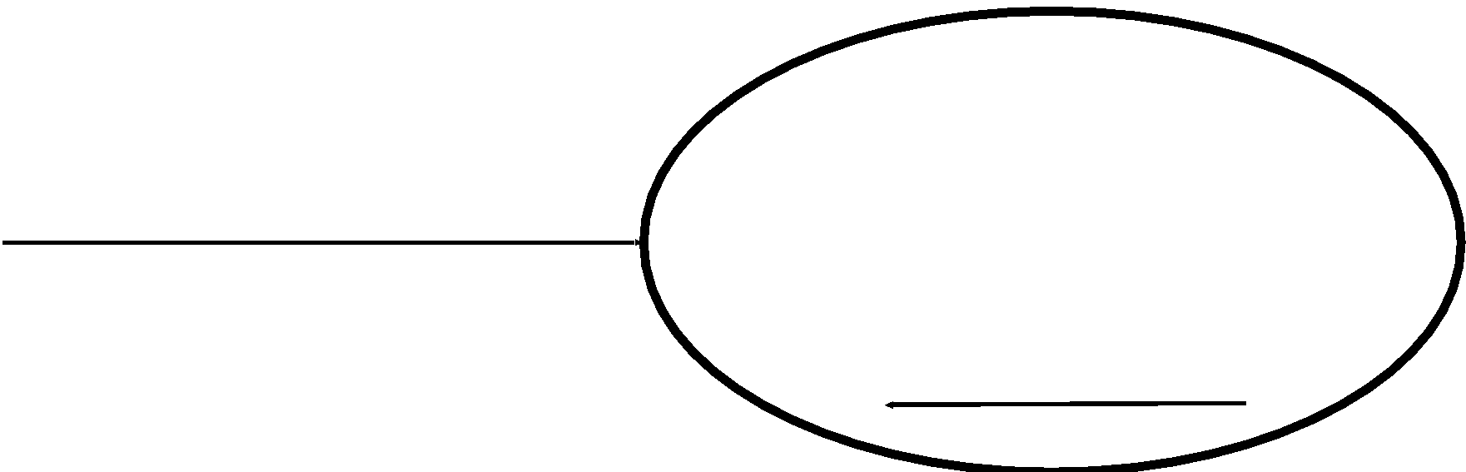 Key attribute

 Multivalued Attribute

ER Diagram of Online Driving School Management System

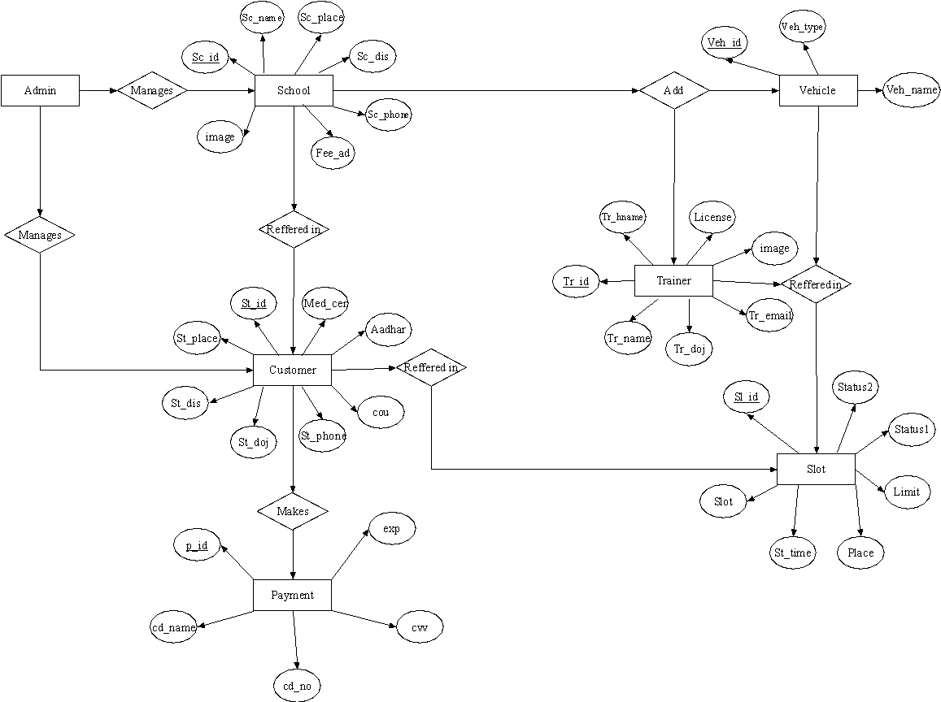

4.1 INPUT DESIGN

Input design is the process of converting a user-oriented description of the inputs to a computer-based system into a programmer-oriented specification. The quality of system input determines the quality of system output. Input specification describes the manner in which data enter the system for processing. Input design features can ensure the reliability of the system and produce result from accurate data or they can result in the production of errors. The input design also determines whether the user can interact efficiently with the system.

Input design requires consideration of the needs of the data entry operator. Three data entry considerations are:

* The field length must be documented
* The sequence of fields must match the sequence of the fields on the source document.
* The data format must be identified to the data entry operator.

In our system almost all inputs are being taken from the databases. To provide adequate inputs we have to select necessary values from the databases and arrange it to the appropriate controls.

Inaccurate input data are the most common cause of errors in data processing. Errors entered by data entry can be controlled by input design. Input design is the process of converting user-oriented inputs to a computer based format. There are three major approaches for entering data into the computer. They are menus, formatted forms and prompts. A menu is a selection list that simplifies computer data access or entry. Instead of remembering what to enter, the user choices from the list of option. A formatted form is a preprinted form or a template that request the user to enter data in appropriate location. It is a fill-in-the-blank type form. The form is flashed on the screen as a unit. In prompt the system displays one enquiry at a time, asking the user for a response.

Home Page

Description: This page shows the homepage.



Login Form

Description: This page shows the login form.

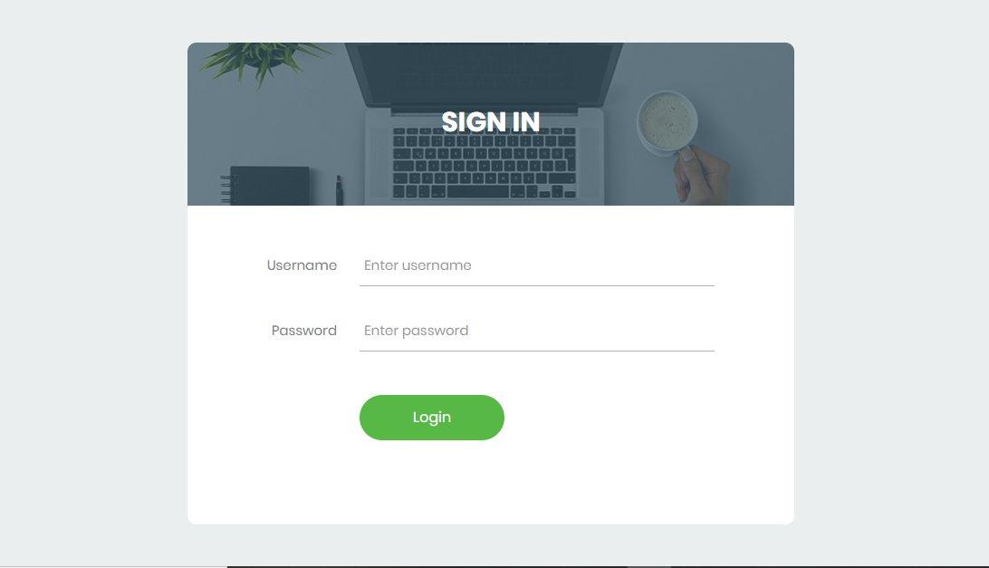

Course Form

Description: This shows the Course page.



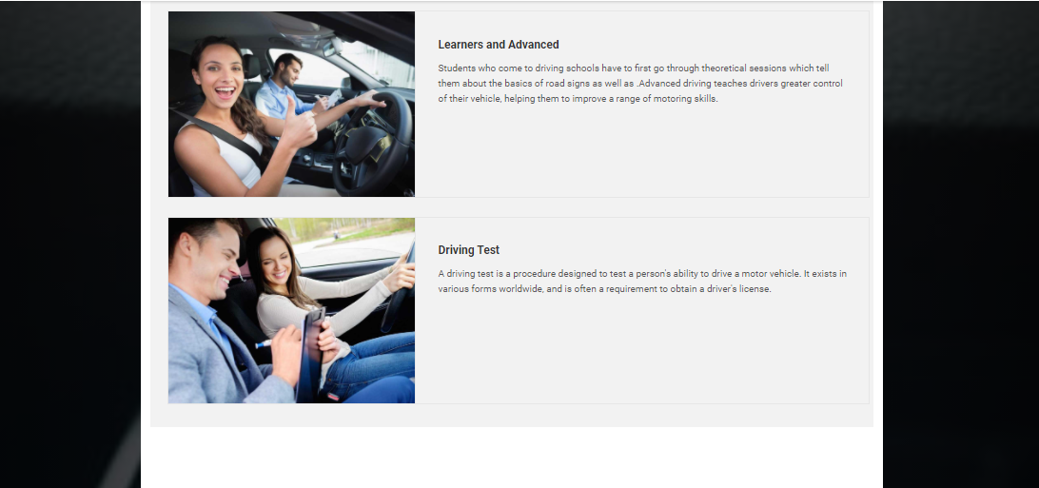

Admin Home Page

Description: This page shows Home page of Admin

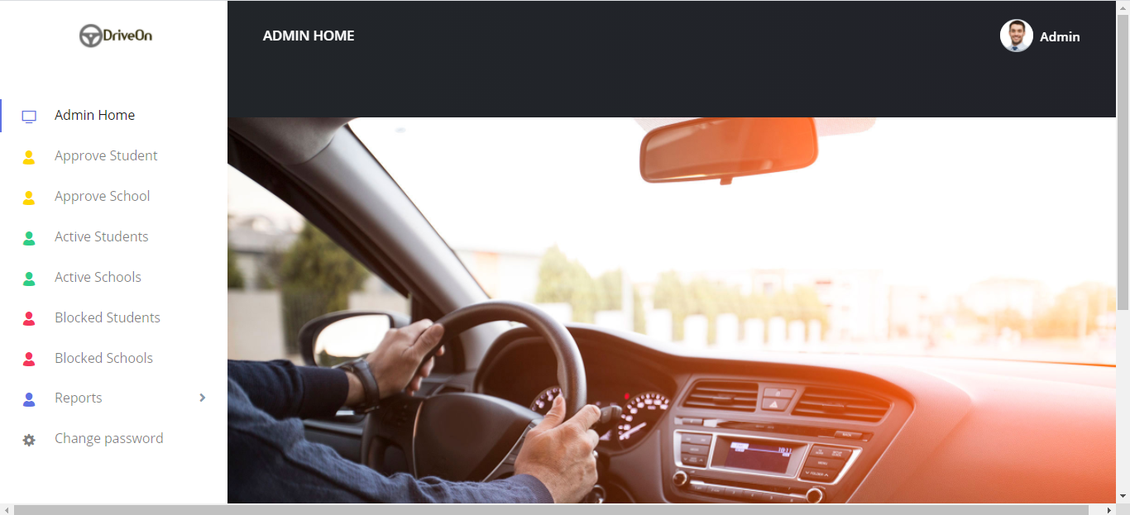

Customer Home Page

Description: This page shows Home page of Customer

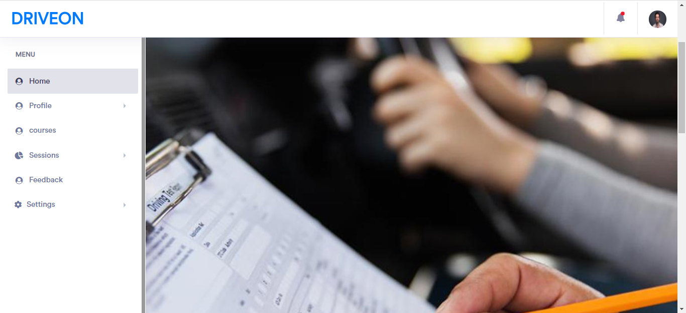

School Home Page

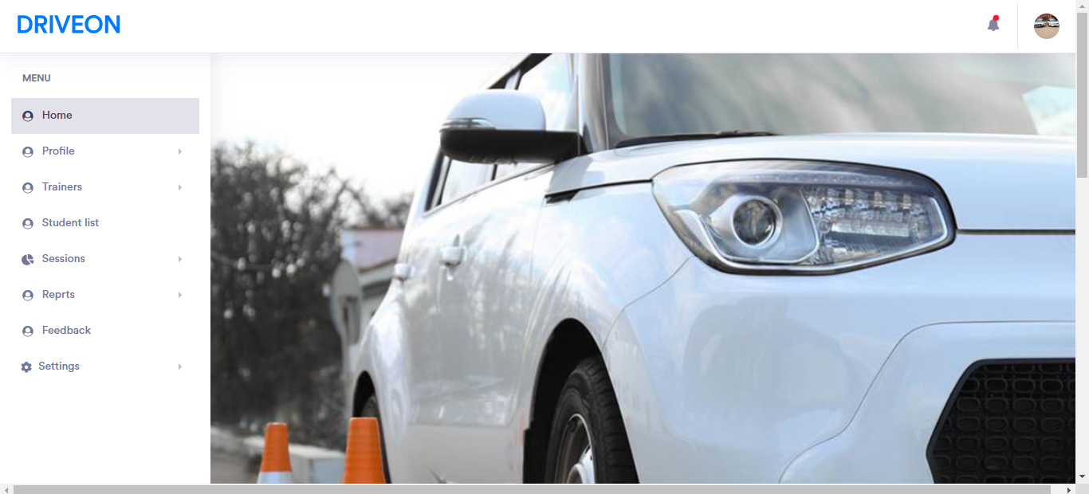Description: This page shows Home page of School

Customer Registration Form

Description: This page shows the register form of Customer

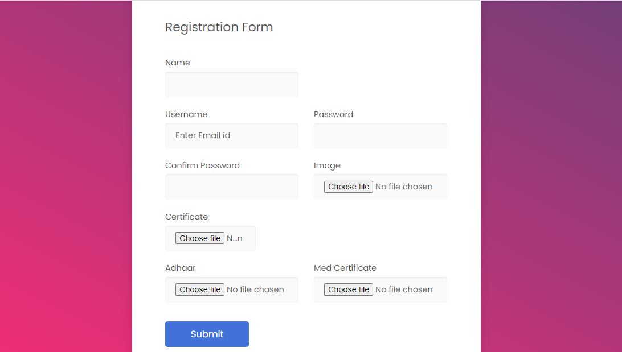

School Registration Form

Description: This page shows the register form of Customer

.

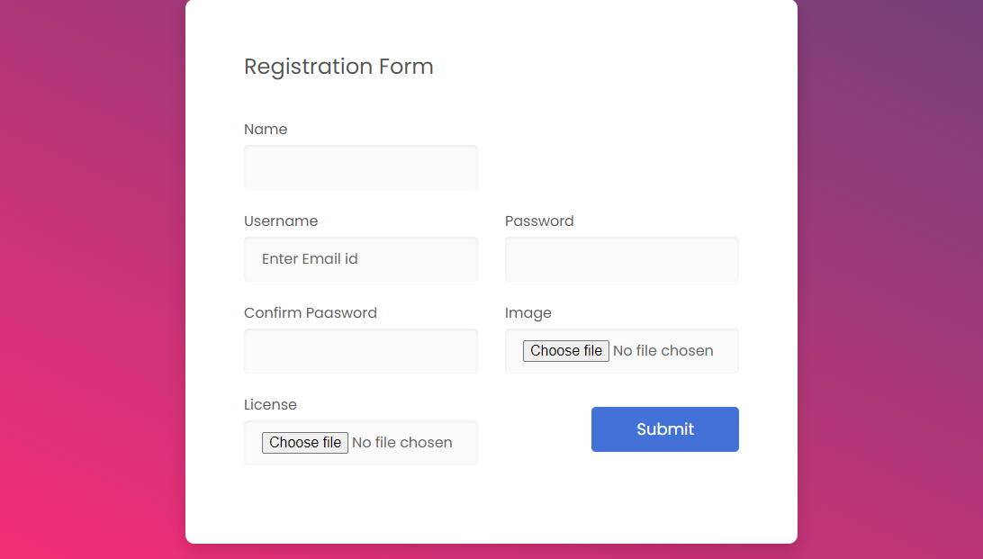

School Profile Complete Page

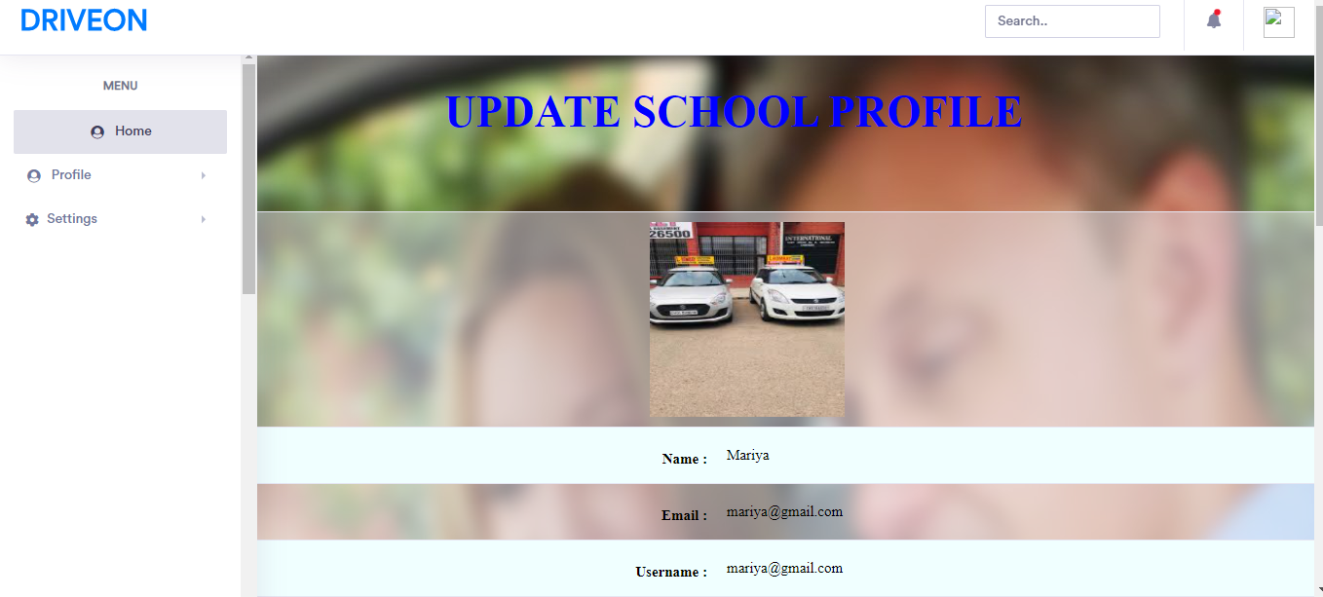Description: This shows the school profile complete page.

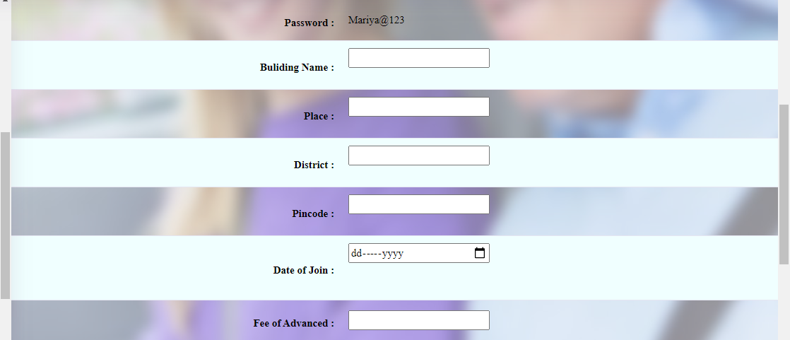

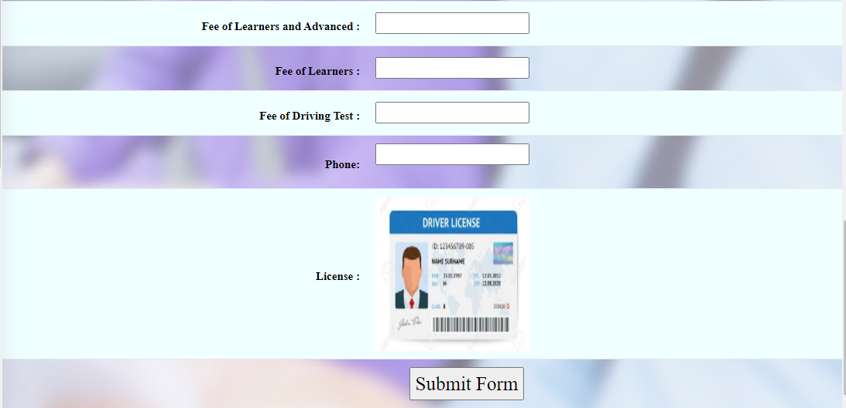

Customer Profile Complete Form

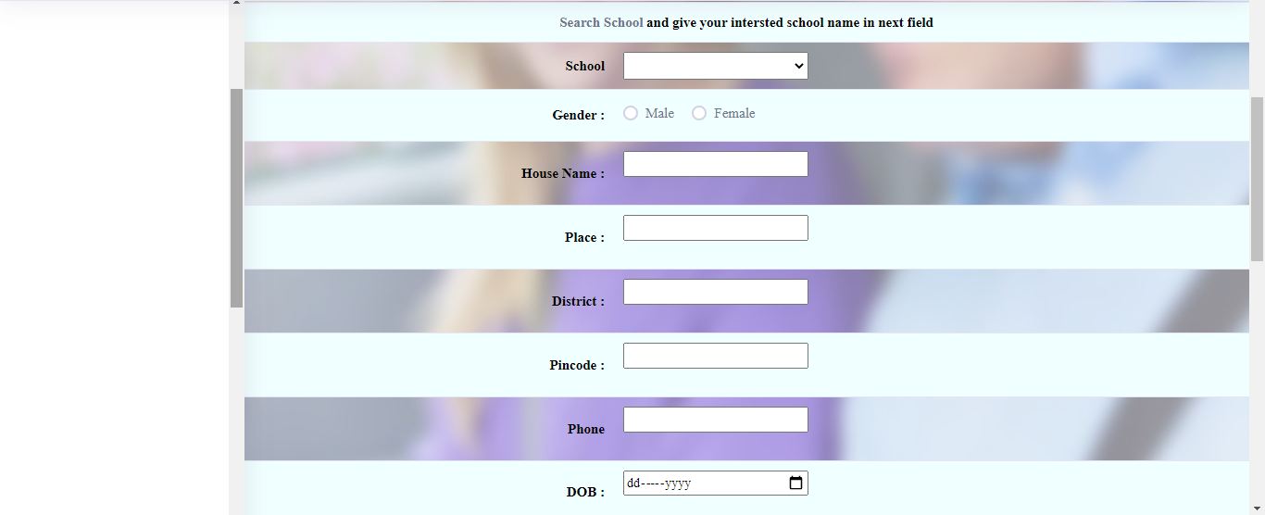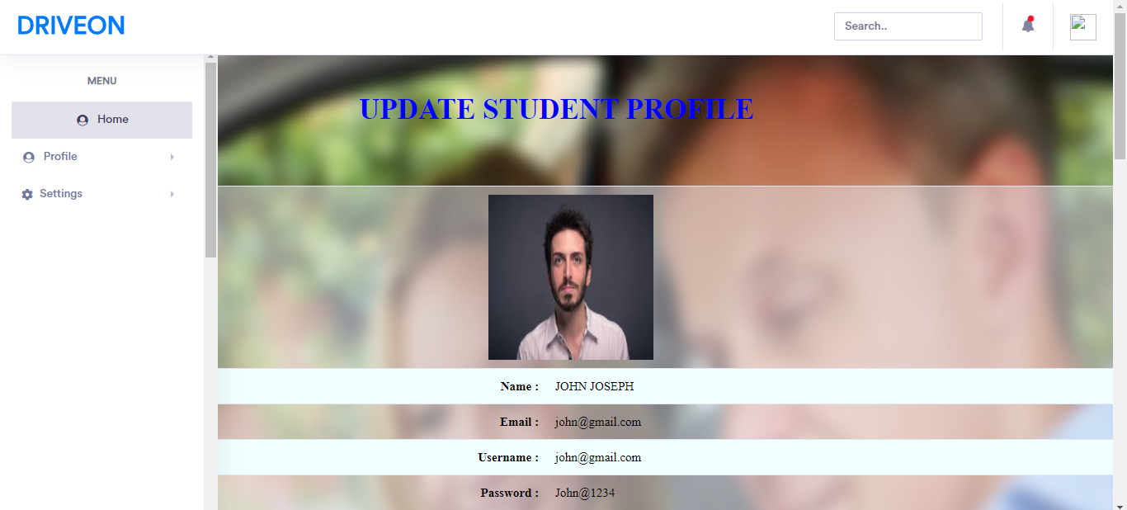Description: This page shows the customer profile complete form

Trainer Registration Form

Description: This page shows the trainer registration form

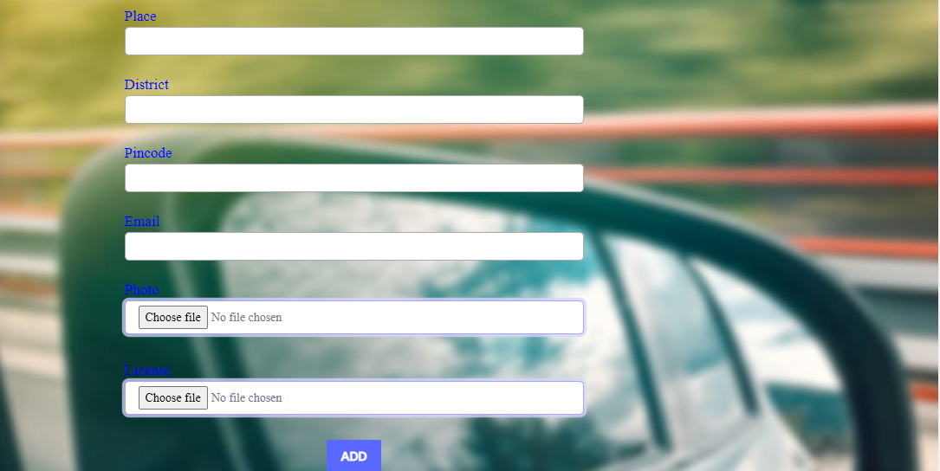

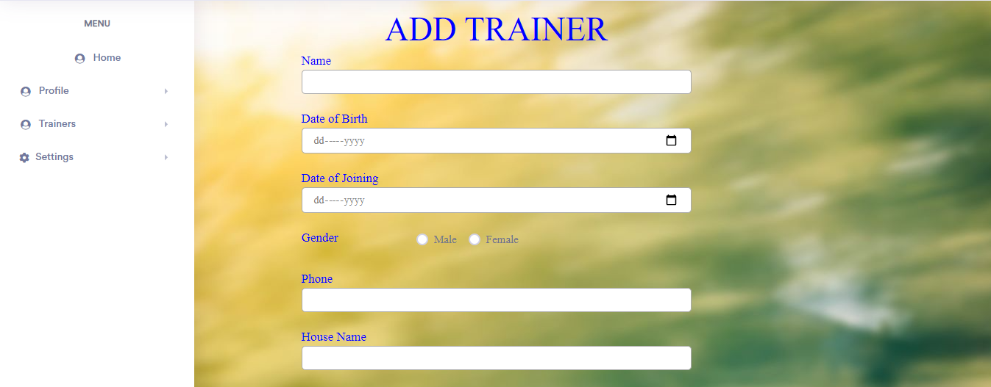

Vehicle Form

Description: This form is used to add vehicle

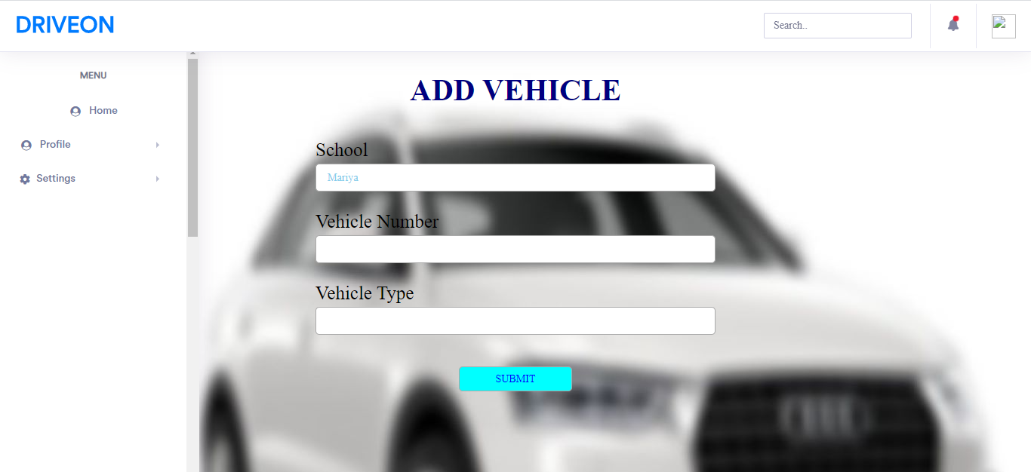

Slot Form

Description: This form is used to add slot

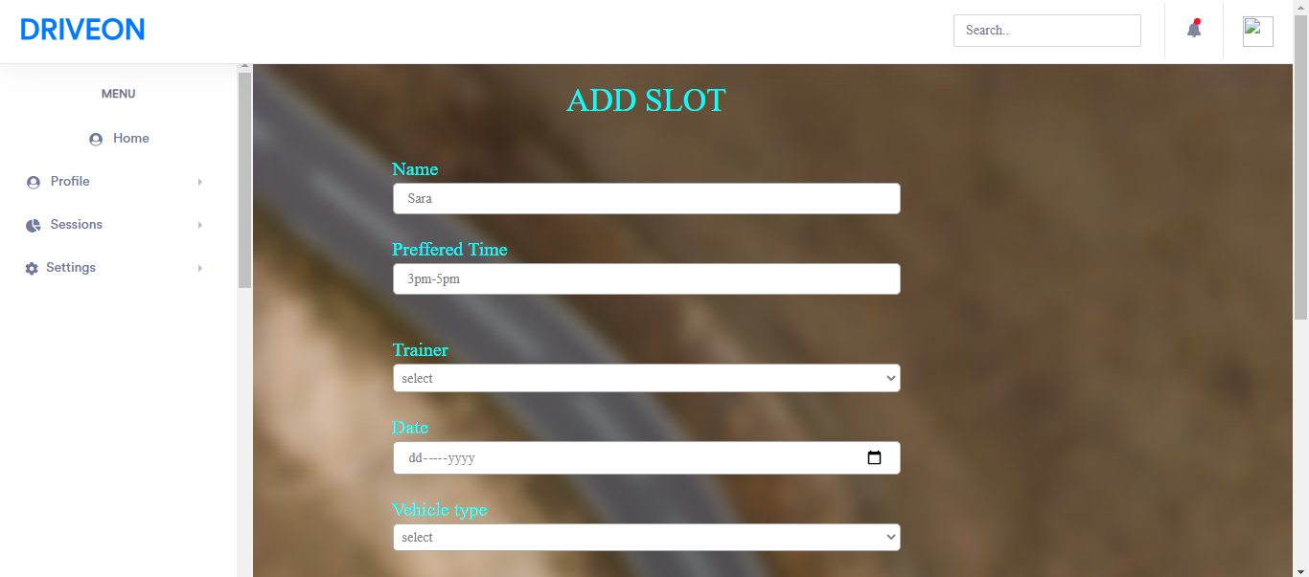

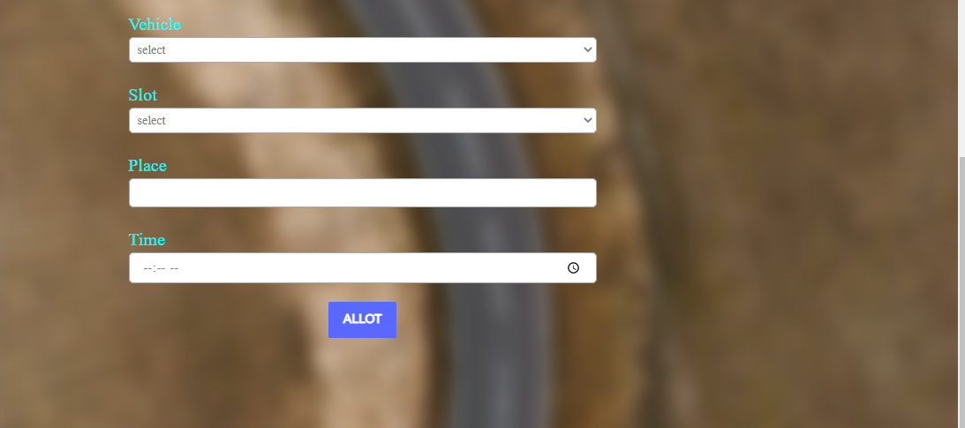

Edit School Details Form

Description: This form is used to edit school details

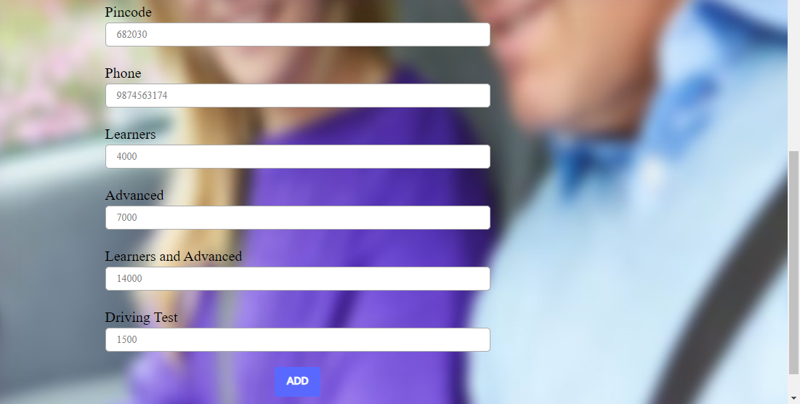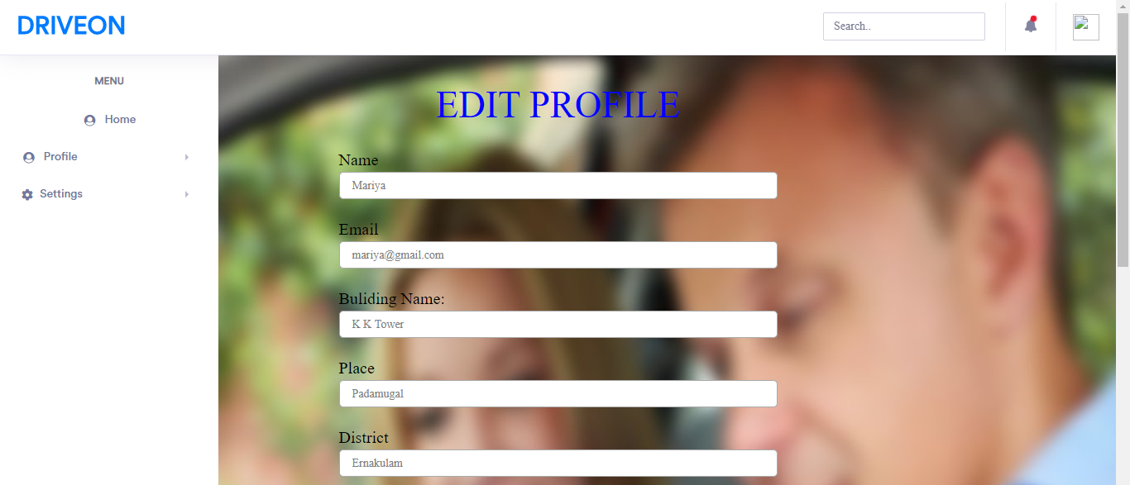

Edit Customer Details

Description: This page shows the register form of Customer

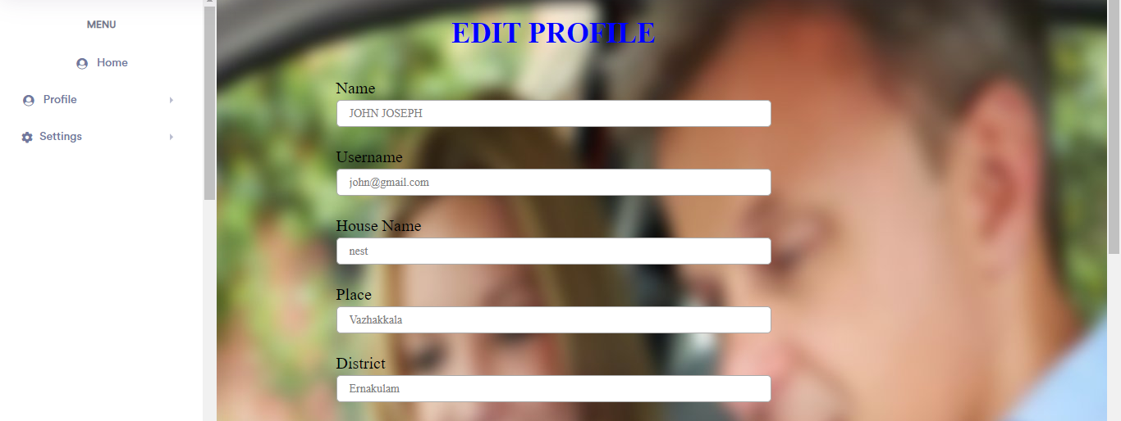



Edit Trainer Details

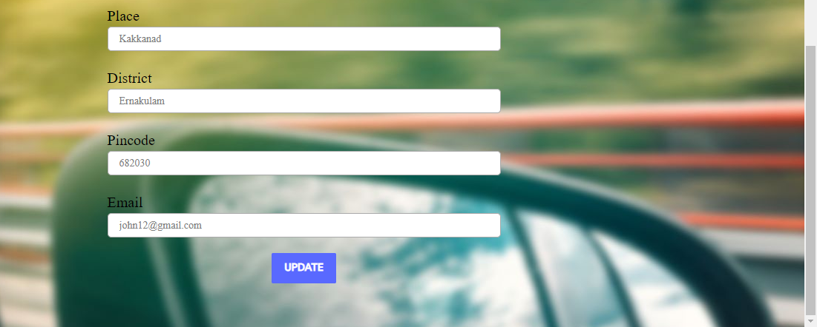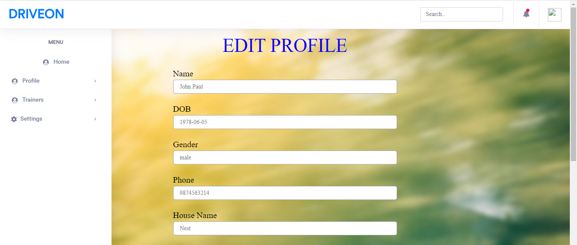Description: This page shows the register form of Customer

4.2 OUTPUT DESIGN

One of the important features of an information system for users is the output it produces. Output is the information delivered to users through the information system. Without quality output, the entire system appears to be unnecessary that users will avoid using it. Uses generally merit the system solely by its output. In order to create the most useful output possible. One works closely with the user through an interactive process, until the result is considered to be satisfactory.

Output design has been an ongoing activity almost from the beginning of the project. In the study phase, outputs were identified and described general in the project directive. A tentative output medium was then selected and sketches made for each output. In the feasibility analysis, a “best” new system was selected; its description identified the input and output media. In the design phase the system has included an evaluation and selection of specific equipment for the system.

Outputs from computer systems are required primarily to communicate the resultsof processing to the user. They are also used to provide a permanent copy of these results for later consultation.

School Details

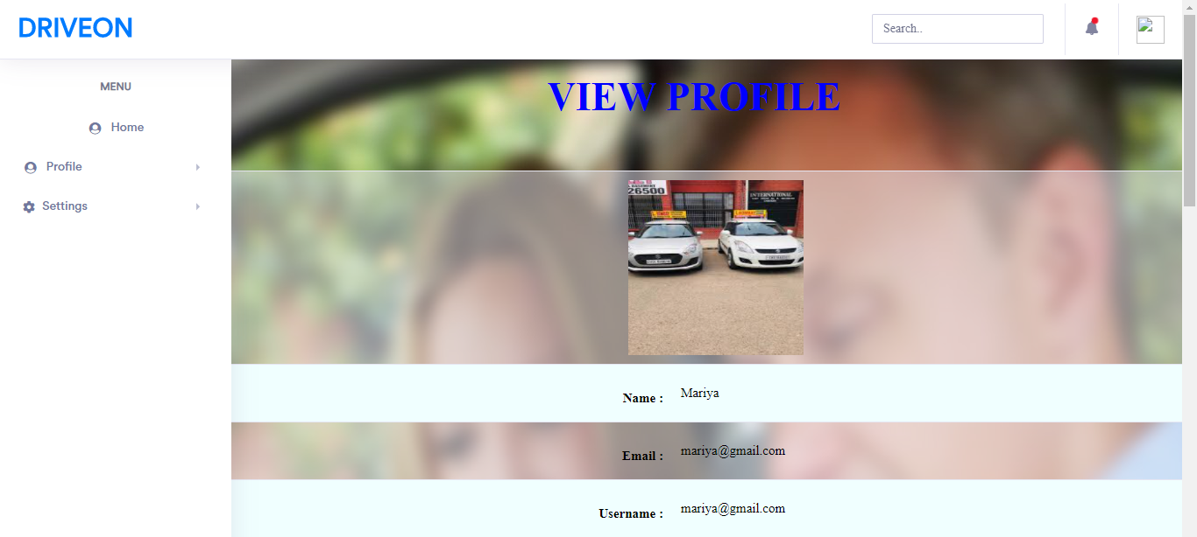Description: This shows details given by School

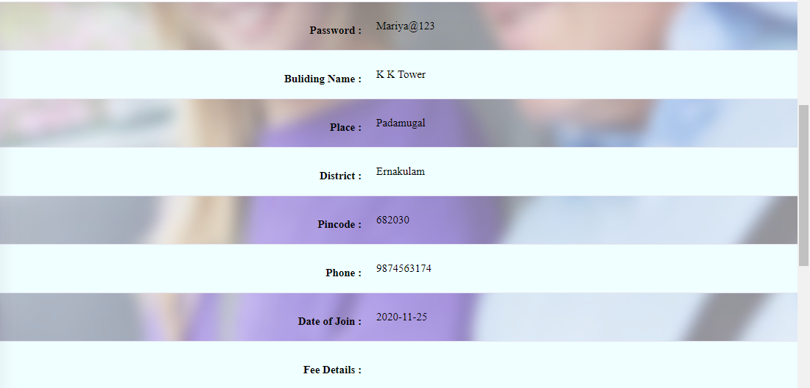

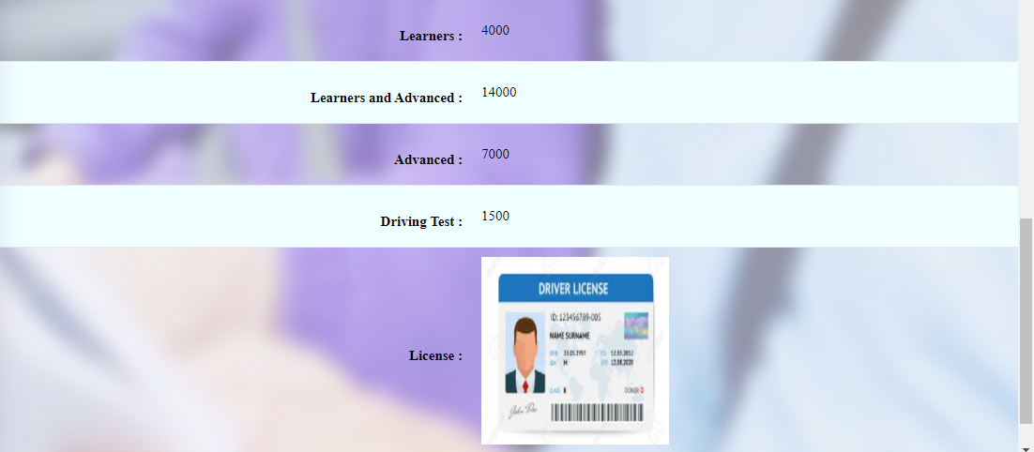

Student Details

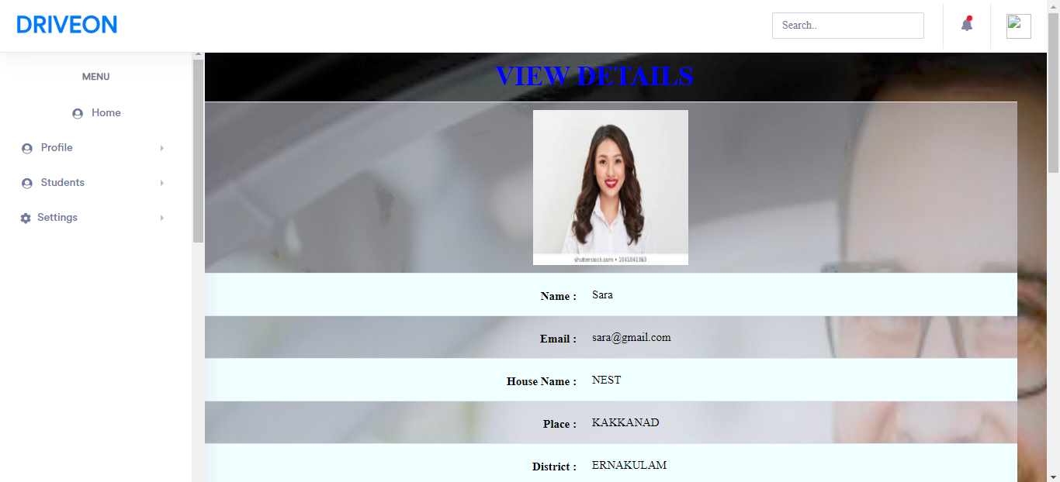Description: This shows details given by Student

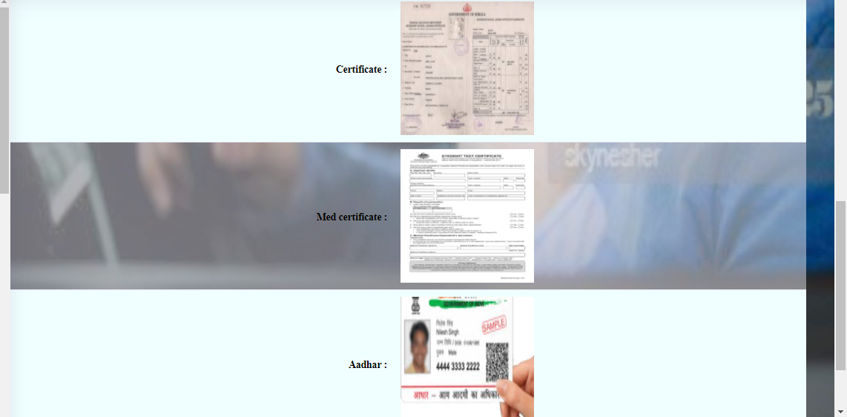

Trainer Details

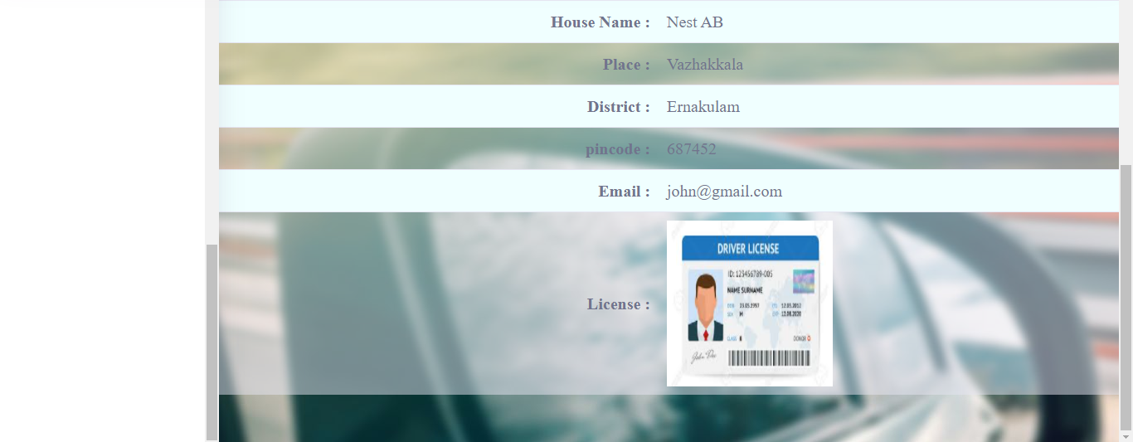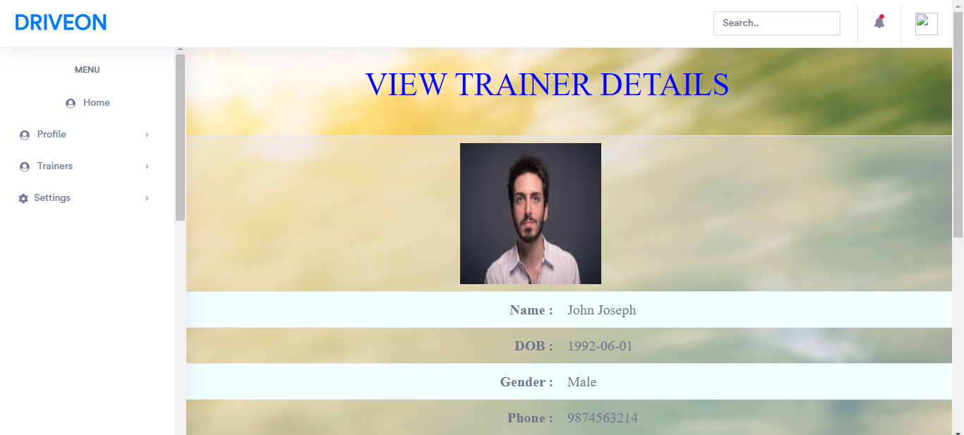Description: This shows details given by Trainer

Student report

Description: This page shows the Student details.

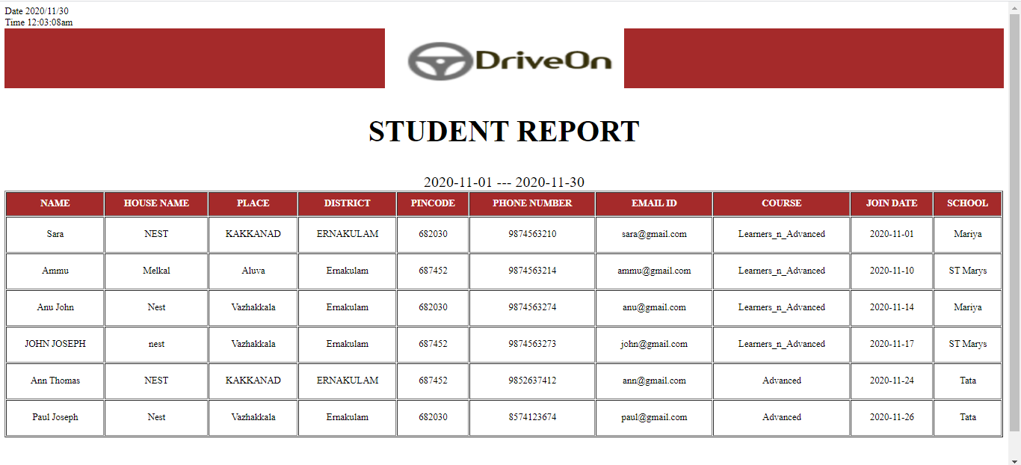

Student Report

Description: This page shows the details of Student according to the school we choose.

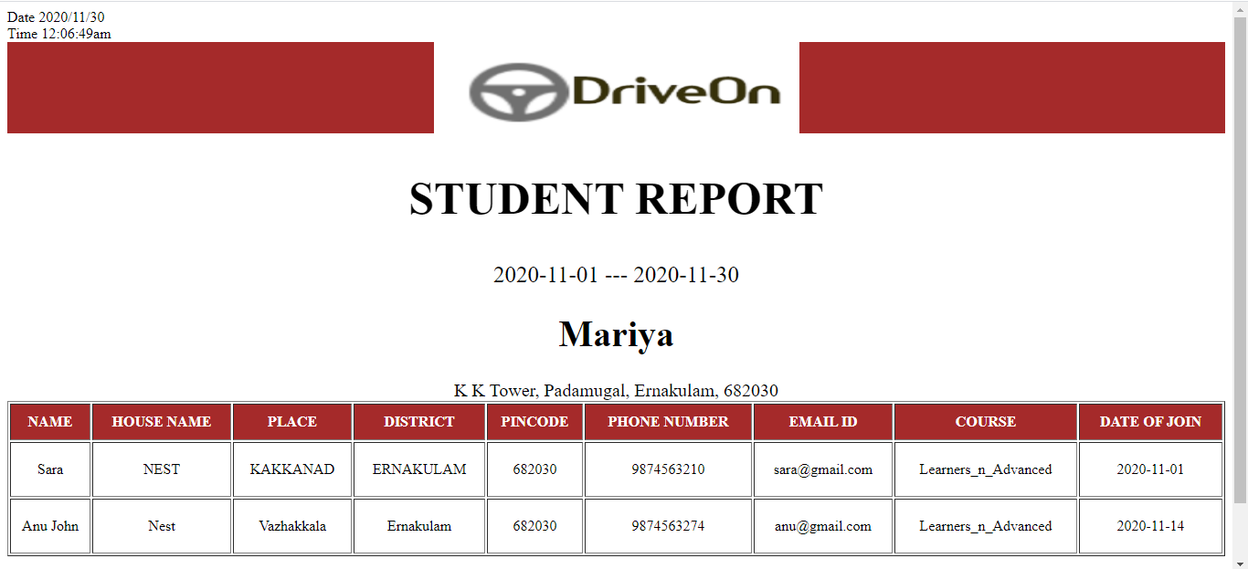

School Report

Description: This page shows the details of the School.

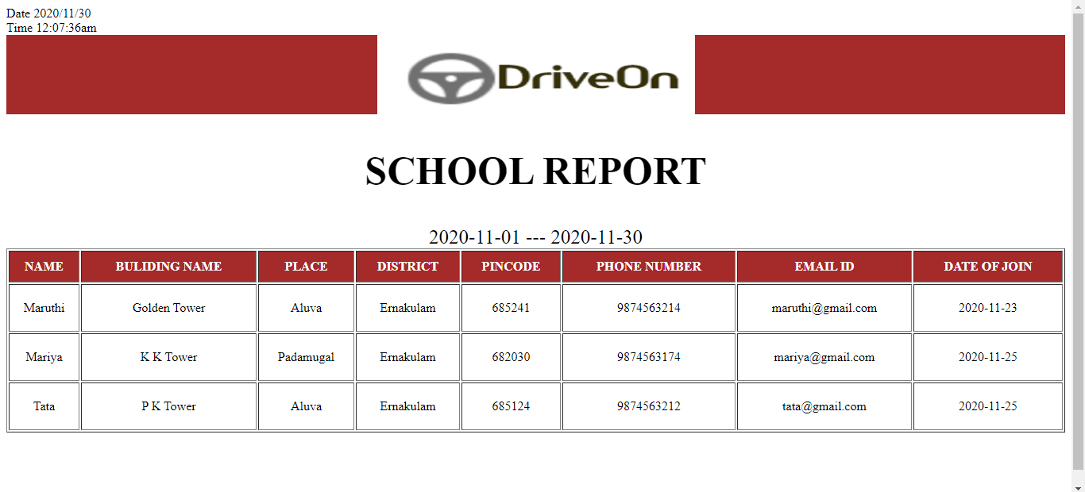

Trainer Report

Description: This page shows the Trainer details according to the school we choose.

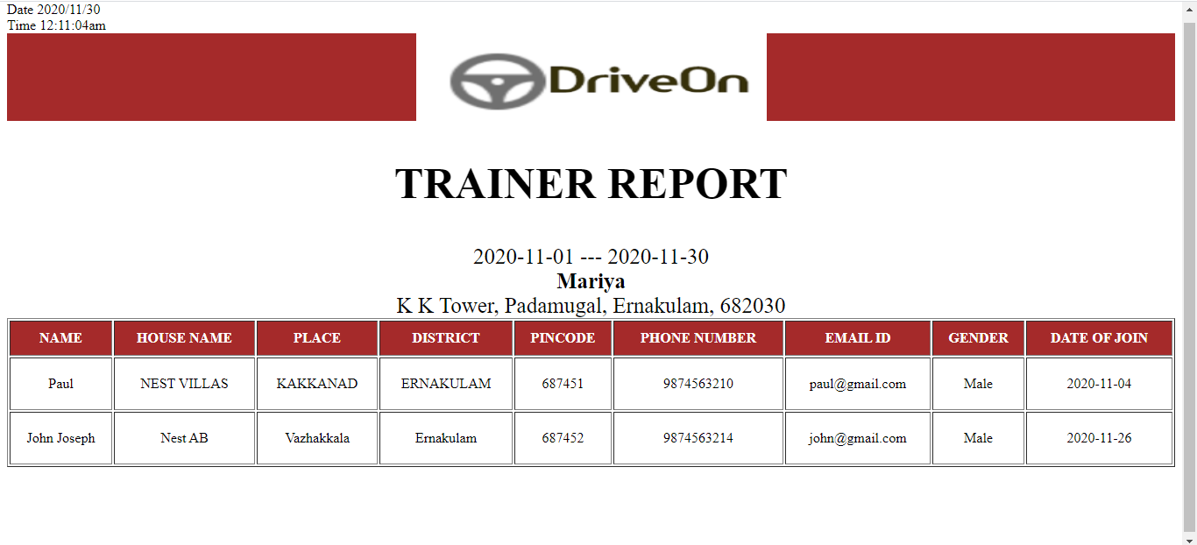

Trainer Report

Description: This page shows the details of all Trainers who is joined in the selected dates.

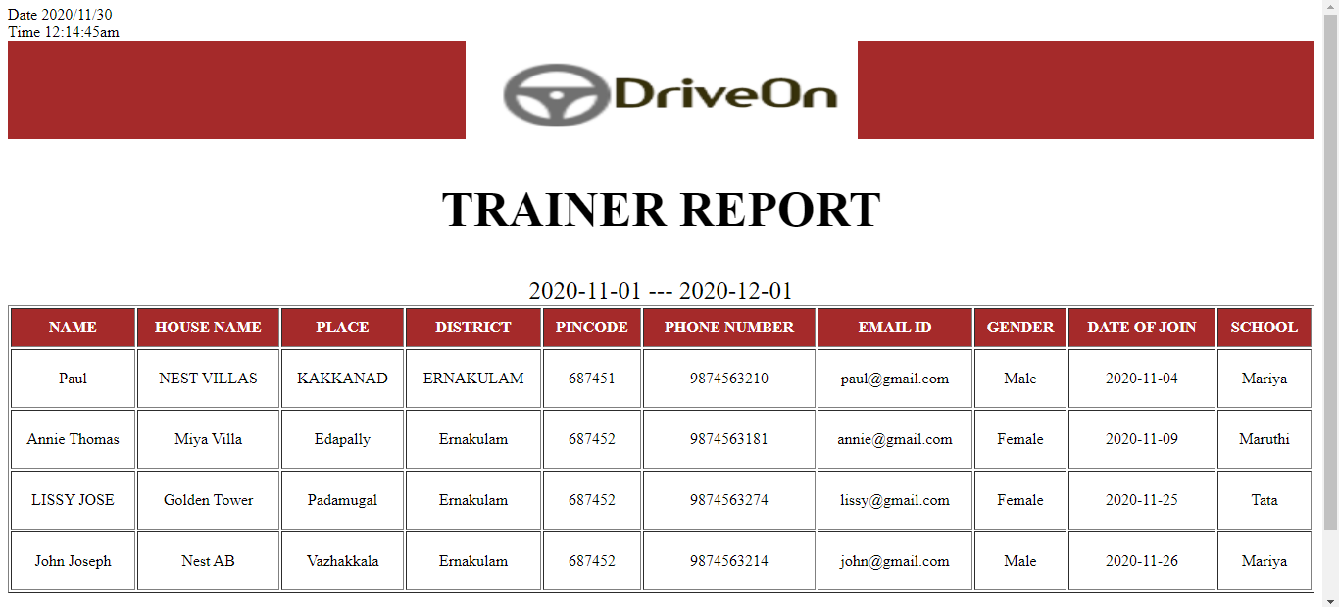

Trainer Report

Description: This page shows the details of Trainer work under that driving school.

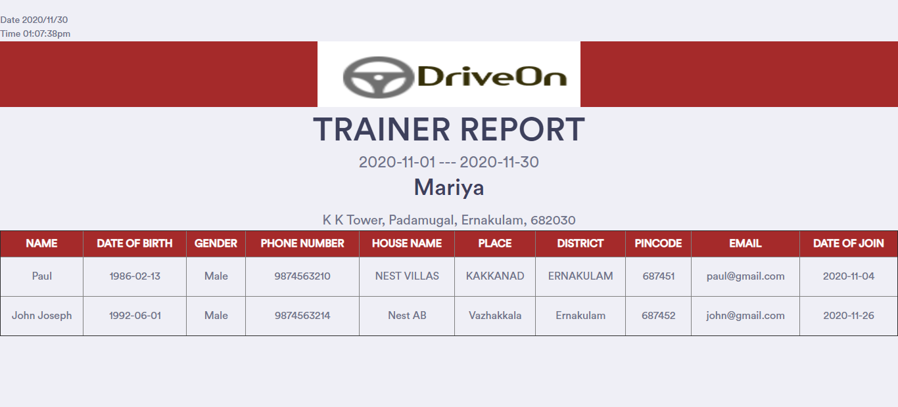

Attendance Report

Description: This page shows the details of all students attended their sessions.

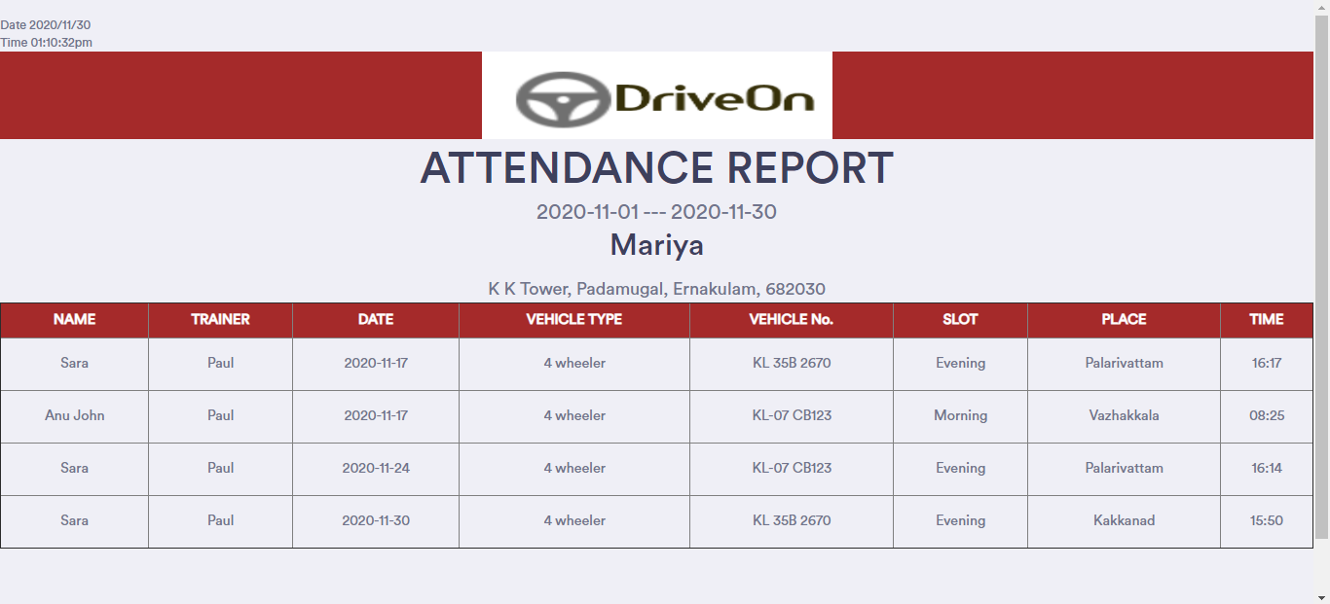

Attendance Report

Description: This page shows the attendance details of selected Student.

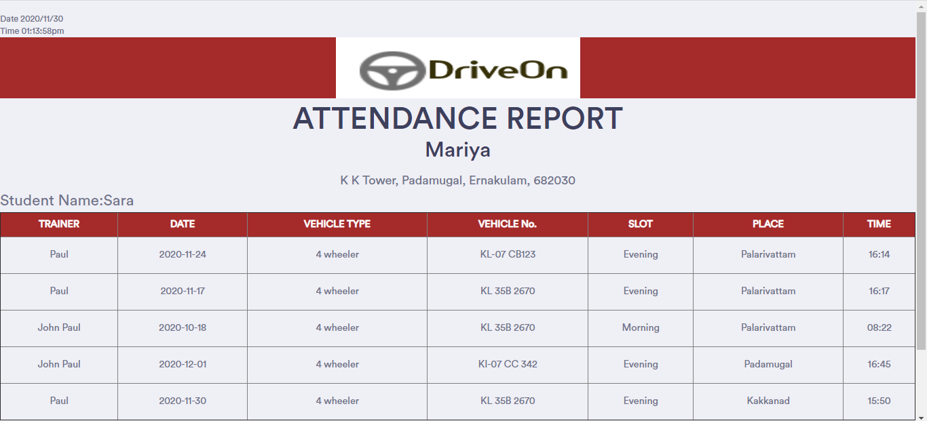

Student Report

Description: This page shows the details of Students trained under a specific trainer.

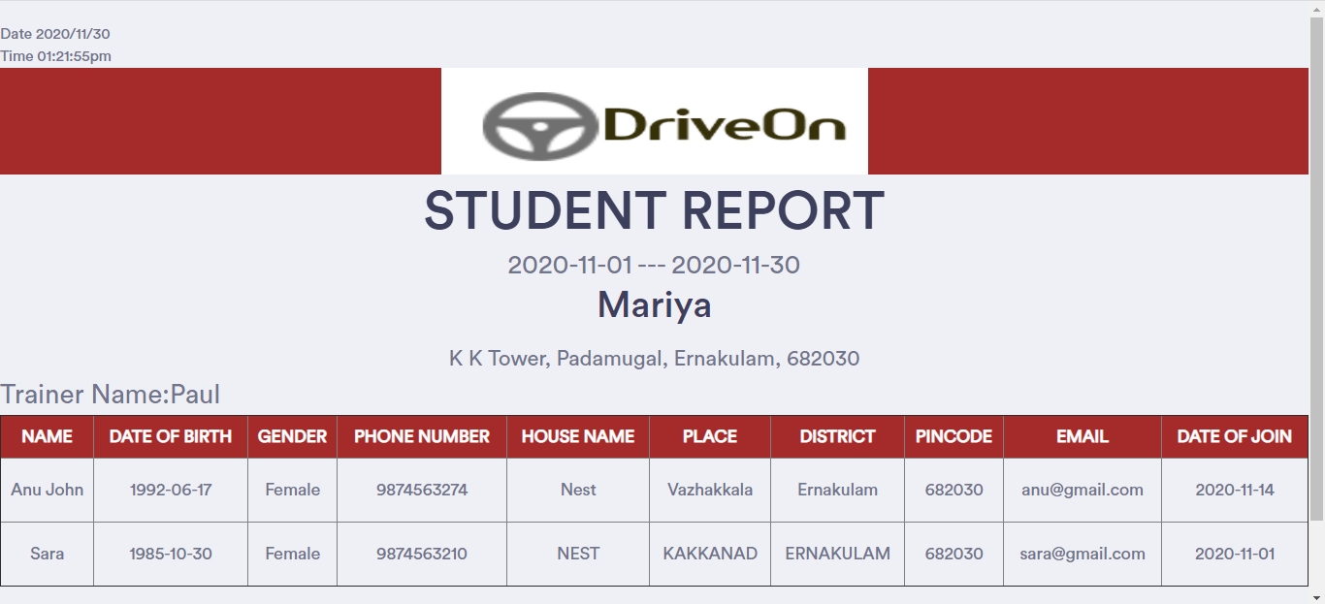

Slot Details

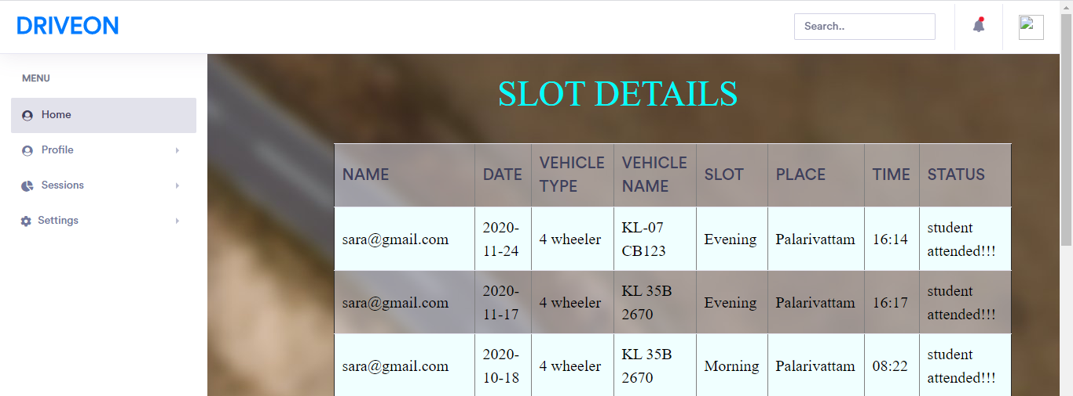Description: This page shows the slot details of students.

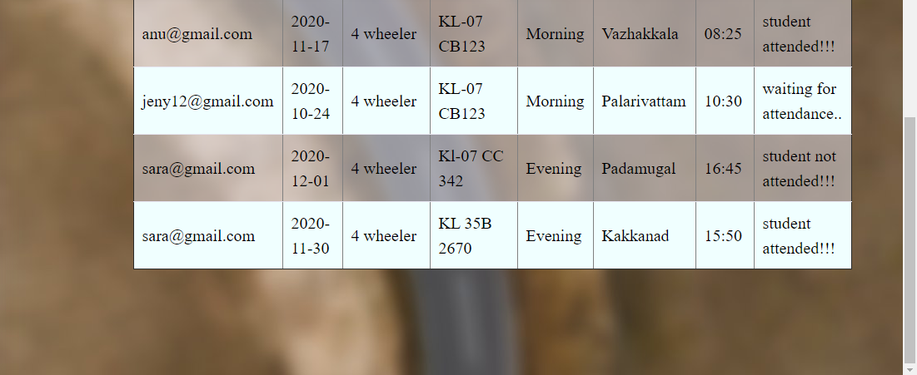

4.3 DATABASE DESIGN

4.3.1 Normalization

Designing a database is a complex task and the normalization theory is a useful aid in this design process. The process of normalization is concerned with transformation of conceptual schema into computer representation form.

A bad database design may lead to certain undesirable situations such as:

* Repetition of information
* Inability to represent certain information
* Loss of information

To minimize these anomalies, normalization may be used. If the database is in a normalized form, the data can be restructured and can maintain it easily. This is important that the databases using that we are using may free from data redundancy and inconsistency. For this need we maintain the tables in a normalized manner.

First Normal Form

A relation is in first Normal Form (1NF), if and only if all its attributes are based on single domain. The objective of normalizing a table is in to remove its repeating groups and ensure that all entries of the resulting table have at most single value.

Second Normal Form

A table is said to be in second Normal Form (2NF), when it is in 1 NF and every attribute in the record is functionally dependent upon the whole key, and not just a part of the key.

Third Normal Form

A table is in third Normal Form (3NF), when it is in 2NF and every non-key attribute is functionally dependent on just the primary key.

TABLE DESIGN

Table Name: tbl_login

Table Description: login details

|  |  |  |  |
| --- | --- | --- | --- |
| FIELD | DATA TYPE | CONSTRAINT | DESCRIPTION |
| username | Varchar(30) | Not null | Email id of user |
| password | Varchar(20) | Not null | Password |
| usertype | Varchar(20) | Not null | Type of user |

**Table Name**: tbl_School

Table Description: School Details

|  |  |  |  |
| --- | --- | --- | --- |
| FIELD | DATA TYPE | CONSTRAINT | DESCRIPTION |
| Sc_id | Varchar(10) | Primary key | School ID |
| Sc_username | Varchar(30) | Foreign Key | Email id of school |
| Sc_name | Varchar(30) | Not null | School Name |
| Sc_hname | Varchar(25) | Null | School Building Name |
| Sc_place | Varchar(20) | Null | School Place |
| Sc_dis | Varchar(20) | Null | School District |
| Sc_pin | Varchar(20) | Null | School Pin code |
| Sc_doj | Date | Null | School Date of Join |
| Sc_phone | Int(10) | Null | Phone Number |
| Fee_le | Int(5) | Null | Fee for Learners |
| Fee_ad | Int(5) | Null | Fee for Advanced |
| Fee_la | Int(5) | Null | Fee for Learners and Advanced |
| Fee_dt | Int(5) | Null | Fee for Driving Test |
| image | Varchar(50) | Not Null | Image of School |
| License | Varchar(50) | Not Null | Image of License of the owner |
| Status | Int(3) | Not Null | Status(Approved, Rejected) |

Table Name: tbl_Customer

**Table Description**: Customer details

|  |  |  |  |
| --- | --- | --- | --- |
| FIELD | DATA TYPE | CONSTRAINT | DESCRIPTION |
| St_id | Varchar(10) | Primary key | Student ID |
| St_username | Varchar(30) | Foreign Key | Email id of student |
| Sc_id | Varchar(30) | Foreign Key | School chosen by Student |
| St_name | Varchar(30) | Not null | Student Name |
| St_hname | Varchar(25) | Null | Student House Name |
| St_place | Varchar(20) | Null | Student Place |
| St_dis | Varchar(20) | Null | Student District |
| St_pin | Varchar(20) | Null | Student Pin code |
| St_dob | Date | Null | Student Date of Birth |
| St_doj | Date | Null | Student Date of Join |
| St_phone | Int(10) | Null | Phone Number |
| gen | Varchar(6) | Null | Gender of Student |
| cou | Varchar(20) | Null | Course chosen by Student |
| time | Varchar(10) | Null | Time chosen by Student |
| image | Varchar(50) | Not Null | Image of Student |
| Med_cer | Varchar(50) | Not Null | Image of Medical Certificate |
| Sc_cer | Varchar(50) | Not Null | Image S S LC |
| Aadhar | Varchar(50) | Not Null | Image of Aadhar |
| Status | Int(10) | Not Null | Status(Approved, Rejected) |

**Table Name**: tbl_Trainer

Table Description: Trainer details

|  |  |  |  |
| --- | --- | --- | --- |
| FIELD | DATA TYPE | CONSTRAINT | DESCRIPTION |
| Tr_id | Varchar(10) | Primary key | Trainer ID |
| Sc_id | Varchar(30) | Foreign Key | School ID |
| Tr_name | Varchar(30) | Not null | Trainer Name |
| Tr_hname | Varchar(25) | Not Null | Trainer House Name |
| Tr_place | Varchar(20) | Not Null | Trainer Place |
| Tr_dis | Varchar(20) | Not Null | Trainer District |
| Tr_pin | Varchar(20) | Not Null | Trainer Pin code |
| Tr_gen | Varchar(10) | Not Null | Trainer Gender |
| Tr_dob | Date | Not Null | Trainer Date of Birth |
| Tr_doj | Date | Not Null | Trainer Date of Join |
| Tr_phone | Int(10) | Not Null | Phone Number |
| Tr_email | Varchar(50) | Not Null | Email id of Trainer |
| image | Varchar(50) | Not Null | Image of Student |
| License | Varchar(50) | Not Null | Image of License |

**Table Name**: tbl_Vehicle

Table Description: subcategory details

|  |  |  |  |
| --- | --- | --- | --- |
| FIELD | DATA TYPE | CONSTRAINT | DESCRIPTION |
| Veh_id | Varchar(10) | Primary Key | Subcategory ID |
| Sc_id | Varchar(20) | Foreign Key | School ID |
| Veh_type | Varchar(20) | Not null | Vehicle Type |
| Veh_name | Varchar(20) | Not null | Vehicle Name |

Table Name: tbl_Payment

Description: Payment details

|  |  |  |  |
| --- | --- | --- | --- |
| FIELD | DATA TYPE | CONSTRAINTS | DESCRIPTION |
| P_id | Varchar(10) | Primary Key | Product ID |
| St_id | Varchar(10) | Foreign Key | Student ID |
| Cd_name | Varchar(30) | Not Null | Card Holder Name |
| Cd_no | Varchar (16) | Not Null | Card Number |
| cvv | Varchar (5) | Not Null | CVV |
| Exp | Date | Not Null | Expiry Date |

Table Name: tbl_Slot

Description: Purchase master details

|  |  |  |  |
| --- | --- | --- | --- |
| FIELD | DATA TYPE | CONSTRAINTS | DESCRIPTION |
| Sl_id | Varchar(10) | Primary key | Slot ID |
| St_id | Varchar(10) | Foreign Key | Student ID |
| Tr_id | Varchar(10) | Foreign Key | Trainer ID |
| Veh_id | Varchar(10) | Foreign Key | Vehicle ID |
| St_dt | Date | Not Null | Slot Date |
| Slot | Varchar(10) | Not Null | Slot Session |
| St_time | Varchar(10) | Not Null | Slot Time |
| Place | Varchar(10) | Not Null | Place |
| Limit | Int(10) | Not Null | Limit of Vehicle |
| Status1 | Int(10) | Not Null | Status(Student Accept or not) |
| Status2 | Int(10) | Not Null | Status(Student Attended or not) |

5.1 INTRODUCTION

Testing is the process of examining the software to compare the actual behavior with that of the excepted behavior. The major goal of software testing is to demonstrate that faults are not present. In order to achieve this goal the tester executes the program with the intent of finding errors. Though testing cannot show absence of errors but by not showing their presence it is considered that these are not present.

System testing is the first Stage of implementation, which is aimed at ensuring that the system works accurately and efficiently before live operations commences. Testing is vital to the success of the system. System testing makes a logical assumption that if all the parts of the system are correct and the goal will be successfully achieved. A series of testing are performed for the proposed system before the proposed system is ready for user acceptance testing.

Levels Of Testing

1. Unit testing
2. Integration testing
3. Validation testing
4. Output testing

Unit testing

In this each module is tested individually before integrating it to the final system. Unit test focuses verification in the smallest unit of software design in each module. This is also known as module testing as here each module is tested to check whether it is producing the desired output and to see if any error occurs.

Integration testing

Integration testing (sometimes called integration and testing, abbreviated I&T) is the phase in software testing in which individual software modules are combined and tested as a group. It occurs after unit testing and before validation testing.

Integration testing takes as its input modules that have been unit tested, groups them in larger aggregates, applies tests defined in an integration test plan to those aggregates, and delivers as its output the integrated system ready for system testing. The purpose of integration testing is to verify functional, performance, and reliability requirements placed on major design items.

Validation testing

In software project management, software testing, and software engineering, validation is the process of checking that a software system meets specifications and that it fulfills its intended purpose. The errors which are uncovered during integration testing are connected during this phase.

Output testing

No system could be useful if it does not produce the required output in the specific format. Output testing is performed to ensure the correctness of the output and its format. The output generated or displayed by the system is tested asking the users about the format required by them.

5.2 TEST CASES

A test plan documents the strategy that will be used to verify and ensure that a product or system meets its design specification and other requirements. A test plan is usually prepared by or with significant input from Test Engineers.

Unit Testing

|  |  |  |  |  |
| --- | --- | --- | --- | --- |
| Form | Procedure | Expected Result | Actual Result | Status |
| Entry Form | Choose whether to Login , Courses or Gallery |  |  |  |
| Login Form | Enter valid username and password | Should validate user and provide link to user accounts | Got entry to accounts | Pass |
| School Form | Enter all mandatory fields | Should validate all entered fields and flash a message indicating successful registration | Message indicating successful registration is shown | Pass |
| Customer Form | Enter all mandatory fields | Should validate all entered fields and flash a message indicating successful registration | Message indicating successful registration is shown | Pass |
| Trainer Form | Enter all mandatory fields | validate all entered fields and flash a message indicating successful registration | Message indicating successful registration is shown | Pass |
| Vehicle Form | Enter all mandatory fields | Should validate all entered fields and flash a message indicating successful entered. | Message indicating successful registration is shown | Pass |
| Slot Form | Enter all mandatory fields | Should validate all entered fields and flash a message indicating successfully entered | Message indicating successful registration is shown | Pass |
| reports | Click the link to show corresponding reports | Should generate reports | Correct report is displayed | Pass |

Integration Testing

|  |  |  |  |
| --- | --- | --- | --- |
| Form | Expected Result | Actual Result | Status |
| Login and user account forms | Get entry to appropriate user page | Appropriate user page is displayed | Pass |
| Trainer Form | Must add Trainer details successfully | Insertion is successful | Pass |
| Vehicle Form | Must add Vehicle details successfully | Insertion is successful | Pass |
| Slot Form | Must add slot details successfully | Insertion is successful | Pass |
| Reports Form | Must display reports | reports displayed | Pass |
| Course page | Display Courses available in driving schools | Course pages displayed | Pass |

Validation Testing

|  |  |  |  |
| --- | --- | --- | --- |
| Form | Expected Result | Actual Result | Status |
| Create user | Check all mandatory fields and validate all entered data fields | If any error found display message and the same screen is displayed else record saved and confirmed | Pass |
| Edit User | Edit the row corresponding to the value entered | If the value entered is invalid error message is thrown otherwise message indicating successful deletion | Pass |

6.1 INTRODUCTION

Implementation is the stage in the project where theoretical design is turned into a working system and is giving confidence on the new system for the users which will work efficiently and effectively. It involves careful planning, investigation of the current system and its constraints on implementations, design of methods to achieve the changeover, an evaluation, of change over methods. Apart from planning major tasks of preparing the implementation are education and training of users. The major complex system being implemented the more evolved will be the system analysis and the design effort required just for implementation. An implementation coordination committee based on policies of individual organisation has been appointed. The implementation process begins with preparing plan for implementation of the system. According to this plan the activities are to be carried out discussions made regarding the equipment and resources and the additional equipment has to be acquired to implement the new system.

Implementation is the final and important phase. The most critical stage in achieving a successful new system and in giving the users confidence that the new system and in giving the users confidence that the new system will work and be effective. The system can be implemented only after thorough testing is done and if found to working according to the specification.

6.2 INSTALLATION PROCEDURE

Installation of software refers to the final installation of the package in the real environment, to the satisfaction of the intended users and the successful operation of the system. In many organizations, those who commission the software development project will not be the one to operate them. In the initial stage, the person who is not sure that the software will make the jobs easier will doubt about the software.

Implementation is the stage of the project where the theoretical design is turned into a working system. At this stage, the main work load, the greatest upheaval and the major impact on the existing system shifts to the user department. If the implementation is not carefully planned and controlled, it can cause confusion.

Implementation includes all those activities that take place to convert from the old system to new one. Proper implementation is essential to provide a reliable system to meet the organizational requirements. Successful implementation may guarantee improvement in the organization using the new system, but improper installation will prevent it. The process of putting the developed system in to actual use is called system implementation.

6.3 IMPLEMENTATION PLAN

The Implementation Plan describes how the information system will be deployed, installed and transitioned into an operational system. The plan contains an overview of the system, a brief description of the major tasks involved in the implementation, the overall resources needed to support the implementation effort, and any site-specific implementation requirements. The plan is developed during the Design Phase and is updated during the Development Phase the final version is provided in the Integration and Test Phase and is used for guidance during the Implementation Phase.

7.1 FUTURE ENHANCEMENT

We have tried our best to present the information effectively, yet there can be further enhancement in the application. We have taken care of all the critical aspects, which were needed to be taken care of. Because of fast changes in the world of programming this system will gradually get outdated and less effective. For the time being its possible to overcome problems by amendments and minor modifications to acknowledge the need of fundamental design.

Though the new system provides base for improving the efficiency of operations, there are a lots of future enhancements that can be added to this project. Keeping this in view, a provision has been made in the system to facilities easy modification updating in the future. Any modification will not affect the normal working of the system.

The development system is very interactive, coded in such a way to ensure maximum user friendliness and also allows flexibility for future.

It can be extended in such a way that:

* Improve the security.
* Improve the performance.

BIBILIOGRAPHY

Websites

Following websites are referred to create this project reports.

* www.stackoverflow.com
* [www.w3schools.com](http://www.w3schools.com)
* www.jquery.com

APPENDICES

APPENDIX A

Sample Source Code/Pseudo Code

Login code

<?php

session_start();

include("includes/connection.php");

include("functions/functions.php");

?>

<!DOCTYPE HTML>

<html>

<head>

<?php

include("top.php");

?>

<script type="text/javascript">

function mail()

{

var mail=/^([a-zA-Z0-9_\.\-])+\@(([a-zA-Z0-9\-])+\.)+([a-zA-Z0-9]{2,4})+$/;

if(document.f1.email.value.search(mail)==-1)

{

alert("Enter valid email");

document.f1.email.focus();

return false;

}

}

functionvalidateform()

{

var mails=/^([a-zA-Z0-9_\.\-])+\@(([a-zA-Z0-9\-])+\.)+([a-zA-Z0-9]{2,4})+$/;

if(document.f1.email.value.search(mails)==-1)

{

alert("Enter valid email");

document.f1.email.focus();

return false;

}

else

{

return true;

}

}

</script>

</head>

<body>

<div class="colorlib-loader"></div>

<div id="page">

<nav class="colorlib-nav" role="navigation">

<div class="top-menu">

<div class="container">

<div class="row">

<div class="col-xs-2">

<div id="colorlib-logo"><a href="home.php"><b>ASIAN PAINT STORE

</b></a></div></div>

<div class="col-xs-10 text-right menu-1"><ul><li>

<ahref="home.php">HOME</a></li>

<li class="has-dropdown"><a href="#">PRODUCTS</a>

<ul class="dropdown">

<?php

getCats();

?>

</ul><li>

<a href="homeabout.php">ABOUT US</a></li>

<li class="active">

<a href="logins.php"><i class="icon-user4"></i> LOG IN</a></li><li>

<a href="register.php"><i class="icon-user2"></i> SIGN UP</a></li></ul>

</div>

</div>

</div>

</div>

</nav>

<aside id="colorlib-hero" class="breadcrumbs">

<div class="flexslider">

<ul class="slides">

<li style="background-image: url(images/p3.jpg);">

<div class="overlay"></div>

<div class="container-fluid">

<div class="row">

<div class="col-md-6 col-md-offset-3 col-sm-12 col-xs-12 slider-text">

<div class="slider-text-inner text-center">

<h1>LOGIN</h1>

</div>

</div>

</div>

</div>

</li></ul>

</div>

</aside>

<center>

<form action="" method="POST" onSubmit="return validateform()" name="f1">

<h1><center>LOGIN</center></h1>

<table>

<tr><td><label>EMAIL:</label></td>

<td><input type="email" name="email" onChange="return mail()" placeholder="EMAIL" required></td></tr>

<tr><td><label>PASSWORD:</label></td>

<td>

<input type="password" name="password" placeholder="PASSWORD" required>

</td></tr>

</table>

<br>

<button type="submit" name="lsubmit" class="registerbtn">LOGIN</button>

<br>

<p>New customer?<a href="register.php"> Sign up</a>.</p>

</form>

</center>

<br><br>

</div>

<div class="gototopjs-top">

<a href="#" class="js-gotop"><i class="icon-arrow-up2"></i></a>

</div>

</body>

</html>

<?php

if(isset($_POST['lsubmit']))

{

$email = $_POST['email'];

$password = $_POST['password'];

$sel_c = "select * from login where password='$password' AND email='$email'";

$run_c = mysqli_query($con, $sel_c);

while($row=mysqli_fetch_array($run_c))

{

$type=$row['type'];

$_SESSION['email']=$row['email'];

$_SESSION['password']=$row['password'];

}

if($type=="admin")

{

echo "<script>alert('You logged in successfully!')</script>";

echo "<script>window.open('adminindex.php','_self')</script>";

}

else if($type=="customer")

{

echo "<script>alert('You logged in successfully!')</script>";

echo "<script>window.open('index1.php','_self')</script>";

}

else

{

echo "<script>alert('invalid userid or password..')</script>";

echo "<script>window.open('logins.php','_self')</script>";

}}

?>

Customer code

<?php

include("functions/functions.php");

include("includes/connection.php");

?>

<!DOCTYPE HTML>

<html>

<head>

<head>

<?php

include("top.php");

?>

<script type="text/javascript">

functionfnam()

{

varfnam=/^[A-Za-z\s]+$/;

if(document.f1.fname.value.search(fnam)==-1)

{

alert("Enter correct full name");

document.f1.fname.focus();

return false;

}

}

function mail()

{

var mail=/^([a-zA-Z0-9_\.\-])+\@(([a-zA-Z0-9\-])+\.)+([a-zA-Z0-9]{2,4})+$/;

if(document.f1.email.value.search(mail)==-1)

{

alert("Enter valid email");

document.f1.email.focus();

return false;

}

}

function phone()

{

var phone=/^\d{10}$/;

if(document.f1.num.value.search(phone)==-1)

{

alert("Enter correct phone number");

document.f1.num.focus();

return false;

}

}

functionadrs()

{

varadrs=/^[A-Za-z\s]+$/;

if(document.f1.address.value.search(adrs)==-1)

{

alert("Enter correct address");

document.f1.address.focus();

return false;

}

}

function city1()

{

var city1=/^[A-Za-z\s]+$/;

if(document.f1.city.value.search(city1)==-1)

{

alert("Enter correct city/district");

document.f1.city.focus();

return false;

}

}

function state1()

{

var state1=/^[A-Za-z\s]+$/;

if(document.f1.state.value.search(state1)==-1)

{

alert("Enter correct state");

document.f1.state.focus();

return false;

}

}

function pass()

{

var pass=/^(?=.*\d)(?=.*[a-z])(?=.*[A-Z]).{6,15}$/;

if(document.f1.password.value.search(pass)==-1)

{

alert("Your password should contain 6-15 characters which contain a numeric digit,an uppercase and a lowercase");

document.f1.password.focus();

return false;

}

}

functionvalidateform()

{

varnam=/^[A-Za-z\s]+$/;

varphn=/^\d{10}$/;

varaddrs= /^[A-Za-z\s]+$/;

var city2= /^[A-Za-z\s]+$/;

var state2= /^[A-Za-z\s]+$/;

var pass1= /^(?=.*\d)(?=.*[a-z])(?=.*[A-Z]).{6,15}$/;

if(document.f1.fname.value.search(nam)==-1)

{

alert("Enter correct full name");

document.f1.fname.focus();

return false;

}

else if(document.f1.email.value.search(mails)==-1)

{

alert("Enter valid email");

document.f1.email.focus();

return false;

}

else if(document.f1.num.value.search(phn)==-1)

{

alert("Enter correct phone number");

document.f1.num.focus();

return false;

}

else if(document.f1.address.value.search(addrs)==-1)

{

alert("Enter correct address");

document.f1.address.focus();

return false;

}

else if(document.f1.city.value.search(city2)==-1)

{

alert("Enter correct city/district");

document.f1.city.focus();

return false;

}

else if(document.f1.state.value.search(state2)==-1)

{

alert("Enter correct state");

document.f1.state.focus();

return false;

}

else if(document.f1.password.value.search(pass1)==-1)

{

alert("Your password should contain 6-15 characters which contain a numeric digit,an uppercase and a lowercase");

document.f1.password.focus();

return false;

}

else if(document.f1.password.value!= document.f1.cpassword.value)

{

alert("Password and Confirm Password Field do not match !!");

document.f1.cpassword.focus();

return false;

}

else

{

return true;

}

}

</script>

</head>

<body>

<div class="colorlib-loader"></div>

<div id="page">

<nav class="colorlib-nav" role="navigation">

<div class="top-menu">

<div class="container">

<div class="row">

<div class="col-xs-2">

<div id="colorlib-logo"><a href="home.php"><b>ASIAN PAINT STORE</b></a>

</div>

</div>

<div class="col-xs-10 text-right menu-1"><ul><li >

<ahref="home.php">HOME</a></li>

<li class="has-dropdown"><a href="#">PRODUCTS</a>

<ul class="dropdown">

<?php

getCats();

?>

</ul><li>

<a href="homeabout.php">ABOUT US</a>

</li><li>

<a href="logins.php"><i class="icon-user4"></i> LOG IN</a></li>

<li class="active">

<a href="register.php"><i class="icon-user2"></i> SIGN UP</a></li></ul>

</div>

</div>

</div>

</div>

</nav>

<aside id="colorlib-hero" class="breadcrumbs">

<div class="flexslider">

<ul class="slides">

<li style="background-image: url(images/p3.jpg);">

<div class="overlay">

</div>

<div class="container-fluid">

<div class="row">

<div class="col-md-6 col-md-offset-3 col-sm-12 col-xs-12 slider-text">

<div class="slider-text-inner text-center">

<h1>REGISTER</h1>

</div>

</div>

</div>

</div>

</li>

</ul>

</div>

</aside>

<center>

<form action="" method="POST" onSubmit="return validateform()" name="f1">

<h1>Register</h1>

<p>Please fill in to create an account.</p>

<hr>

<table>

<tr><td><label>FULL NAME:</label></td>

<td><input type="text" name="fname" onChange="return fnam()" placeholder="enter name" required></td></tr>

<tr><td><label>MOBILE NUMBER:</label></td>

<td><input type="text" name="num" onChange="return phone()" placeholder="enter mobile number" required></td></tr>

<tr><td><label>EMAIL:</label></td>

<td><input type="email" name="email" onChange="return mail()" placeholder="enter email" required></td></tr>

<tr><td><label>STATE:</label></td>

<td><input type="text" name="state" onChange="return state1()" placeholder="enter state" required></td></tr>

<td><label>PASSWORD:</label></td>

<td><input type="password" name="password" onChange="return pass()" placeholder="enter password" required></td></tr>

<td><label>CONFIRM PASSWORD:</label></td>

<td><input type="password" name="cpassword" placeholder="confirm password" required></td></tr>

</table>

<tr>

By creating an account you agree to our <a href="#">Terms & Conditions</a>

</tr>

<br>

<button type="submit" name="register" class="registerbtn">Register</button>

<br>

<p>

Already have an account? <a href="logins.php">Sign in</a>.

</p>

</form>

</center>

</body>

</html>

<?php

if(isset($_POST['register']))

{

$c_fname= $_POST['fname'];

$c_number= $_POST['num'];

$c_email= $_POST['email'];

$c_password= $_POST['password'];

$c_cpassword= $_POST['cpassword'];

$selemail = "select * from customer where email='$c_email'";

$runemail= mysqli_query($con, $selemail);

$selnum = "select * from customer where num='$c_number'";

$runnum= mysqli_query($con, $selnum);

$selpass = "select * from customer where password='$c_password'";

$runpass= mysqli_query($con, $selpass);

if(mysqli_num_rows($runemail) > 0)

{

echo "<script>alert('sorry this email id already taken')</script>";

}

else if(mysqli_num_rows($runnum) > 0)

{

echo "<script>alert('sorry this number already exists')</script>";

}

else if(mysqli_num_rows($runpass) > 0)

{

echo "<script>alert('sorry,enter a unique password')</script>";

}

else

{

$insert= "INSERT INTO customer(name,num,email,address,city,state,password)VALUES('$c_fname','$c_number','$c_email','$c_addres','$c_city','$c_state','$c_password')";

$runreg= mysqli_query($con, $insert);

$insertlog="INSERT INTO login(email,password,type)VALUES('$c_email','$c_password','customer')";

$runlog= mysqli_query($con, $insertlog);

if($runreg and $runlog)

{

echo "<script>alert('registration successful')</script>";

echo "<script>window.open('logins.php?runreg','_self')</script>";

}

else

{

echo "<script>alert('invalid entry!')</script>";

}}}

?>

Edit customer account code

<?php

include("includes/connection.php");

include("functions/functions.php");

session_start();

if(!isset($_SESSION['email']))

{

echo "<script>alert('you are not logged in,please login to continue!')</script>";

echo "<script>window.open('../home.php?view_cats','_self')</script>";

}

?>

<!DOCTYPE HTML>

<html>

<head>

<?php

include("top.php");

?>

<script type="text/javascript">

functionfnam()

{

varfnam=/^[A-Za-z\s]+$/;

if(document.f1.name.value.search(fnam)==-1)

{

alert("Enter correct username");

document.f1.name.focus();

return false;

}

}

function phone()

{

var phone=/^\d{10}$/;

if(document.f1.num.value.search(phone)==-1)

{

alert("Enter correct phone number");

document.f1.num.focus();

return false;

}

}

functionadrs()

{

varadrs=/^[A-Za-z\s]+$/;

if(document.f1.address.value.search(adrs)==-1)

{

alert("Enter correct address");

document.f1.address.focus();

return false;

}

}

function city1()

{

var city1=/^[A-Za-z\s]+$/;

if(document.f1.city.value.search(city1)==-1)

{

alert("Enter correct city/district");

document.f1.city.focus();

return false;

}

}

function state1()

{

var state1=/^[A-Za-z\s]+$/;

if(document.f1.state.value.search(state1)==-1)

{

alert("Enter correct state");

document.f1.state.focus();

return false;

}

}

functionvalidateform()

{

varnam=/^[A-Za-z\s]+$/;

varphn=/^\d{10}$/;

varaddrs=/^[A-Za-z\s]+$/;

var city2= /^[A-Za-z\s]+$/;

var state2= /^[A-Za-z\s]+$/;

if(document.f1.name.value.search(nam)==-1)

{

alert("Enter correct username");

document.f1.name.focus();

return false;

}

else if(document.f1.num.value.search(phn)==-1)

{

alert("Enter correct phone number");

document.f1.num.focus();

return false;

}

else if(document.f1.address.value.search(addrs)==-1)

{

alert("Enter correct address");

document.f1.address.focus();

return false;

}

else if(document.f1.city.value.search(city2)==-1)

{

alert("Enter correct city/district");

document.f1.city.focus();

return false;

}

else if(document.f1.state.value.search(state2)==-1)

{

alert("Enter correct state");

document.f1.state.focus();

return false;

}

else

{

return true;

}

}

</script>

</head>

<body

<div class="colorlib-loader"></div>

<div id="page">

<nav class="colorlib-nav" role="navigation">

<div class="top-menu">

<div class="container">

<div class="row">

<div class="col-xs-2"><div id="colorlib-logo">

<a href="../index.php"><b>ASIAN PAINT STORE</b></a></div>

</div>

<div class="col-xs-10 text-right menu-1"><ul>

<li><a href="../index1.php">HOME</a></li>

<li class="has-dropdown" ><a href="#">PRODUCTS</a>

<ul class="dropdown">

<?phpgetCats(); ?>

</ul></li>

<li><a href="about.php">ABOUT US</a></li>

<li class="has-dropdown" class="active"><a href="#">MY ACCOUNT</a> <ul class="dropdown">

<li><a href="editcustomer.php?mail=<?php echo $_SESSION['email']; ?>">EDIT ACCOUNT</a></li>

<li><a href="changepassword.php">CHANGE PASSWORD</a></li>

<li><a href="trackorder.php">TRACK ORDER</a></li>

</ul><li><a href="cart.php"><i class="icon-shopping-cart"></i> MY CART</a></li>

<li><a href="../logout.php"><i class="icon-log-out"></i> LOG OUT</a></li></ul>

<ul>

<?php

if(isset($_SESSION['email'])

{

$selcust= "select * from customer where email='$_SESSION[email]'";

$runcust=mysqli_query($con,$selcust);

while($getcust=mysqli_fetch_array($runcust))

{

$name=$getcust['name'];

}

echo "<b>Welcome : </b>" . $name . "";

} ?>

</ul></ul></div></div></div>

</div>

</nav>

<aside id="colorlib-hero" class="breadcrumbs">

<div class="flexslider">

<ul class="slides">

<li style="background-image: url(../images/p2.jpg);">

<div class="overlay"></div>

<div class="container-fluid">

<div class="row">

<div class="col-md-6 col-md-offset-3 col-sm-12 col-xs-12 slider-text">

<div class="slider-text-inner text-center">

<h1><b>EDIT CUSTOMER</b></h1>

<h2 class="bread"><span><a href="../index.php">Home</a></span></h2>

</div></div></div></div></li></ul>

</div>

</aside>

<center>

<form action="" method="post" onSubmit="return validateform()" name="f1">

<table>

<?php

if(isset($_GET['mail']))

{

$email= $_GET['mail'];

$sql ="select * from customer where email='$email'";

}

$result= mysqli_query($con, $sql);

while($row = mysqli_fetch_array($result))

{

?>

<h3>Change the details and click update</h3>

<tr><th>CUSTOMER ID</th>

<td><input type="text" name="c_id" value="<?php echo $row['c_id'] ?>" readonly></td></tr>

<tr><th>USERNAME</th><td ><input type="text" name="name" onChange="return fnam()" value="<?php echo $row['name'] ?>"></td></tr>

<tr><th>PHONE NO:</th>

<td><input type="text" name="num" onChange="return phone()" value="<?php echo $row['num'] ?>"></td></tr>

<tr><th>EMAIL:</th>

<td><input type="text" name="email" value="<?php echo $row['email'] ?>" readonly></td></tr>

</tr>

<?php }?>

</table>

<br>

<input type="submit" name="addreg" value="update">

<input type="reset" name="reset" value="Clear">

</form>

</center>

<br>

</div>

<div class="gototopjs-top">

<a href="#" class="js-gotop"><i class="icon-arrow-up2"></i></a>

</div>

</body>

</html>

<?php

if(isset($_POST['addreg']))

{

$c_id= $_POST['c_id'];

$name= $_POST['name'];

$num= $_POST['num'];

$email= $_POST['email'];

$address= $_POST['address'];

$city= $_POST['city'];

$state= $_POST['state'];

$sql= "update customer set name='$name',num='$num',email='$email',address='$address',city='$city',state='$state' where c_id='$c_id'";

$result=mysqli_query($con, $sql);

if($result)

{

echo "<script>alert('updated successfully!')</script>";echo "<script>window.open('editcustomer.php?mail=$email','_self')</script>";}}?>

APPENDIX B

Acronyms

ER- Entity relation

PHP –PHP Hypertext Preprocessor

SQL-Structured Query Language

DFD-Data Flow Diagram

INF-First Normal Form

2NF-Second Normal Form

3NF-Third Normal Form